Document: FCILekha Treasury User Guide | Version:12.0



Error: Reference source not found

User Guide Treasury



MAY 2019

Confidentiality

© 2018 TECH MAHINDRA

This document contains information that is proprietary and confidential to TECH MAHINDRA, which shall not be disclosed outside Food Corporation of India, transmitted, or duplicated, used in whole or in part for any purpose other than its intended purpose. Any use or disclosure in whole or in part of this information without express written permission of TECH MAHINDRA is prohibited. Any other company and product names mentioned are used for identification purposes only, and may be trademarks of their respective owners.

Document Control

Revision Details

Date | Author | Version | Change Reference
14-Aug-2013 | TCS | 1.1 | Functionalities, processes, requests
04-Sep-2013 | TCS | 1.2 | Removal of Receipts/Payments from Treasury.
04-Apr-2016 | TCS | 12.0 | FAP R12 Upgrade

Distribution

Copy No. | Name | Location | Role | Position | Date
1 | FCILekha | Delhi HQ
2

DOCUMENT RELEASE NOTICE

Notice No. :
Client : Food Corporation of India
Project : Oracle Application 11i Implementation at FCI.
Document Details:

Name | Version No. | Description
FCI User Guide - Treasury | 1.0 | User Guide for Treasury.

Revision Details:

Action taken  (Add / delete / change) | Preceding  Page No. | New  Page No. | Revision  Description

Change Register serial numbers covered:
The documents or revised pages are subject to document control.
Please keep them up-to-date using the release notices from the distributor of the document.
These are confidential documents. Unauthorized access or copying is prohibited.

Approved by: Date:

Authorized by: Date:

DOCUMENT REVISION LIST

Client : Food Corporation of India
Project : Oracle Application 11i Implementation at FCI.
Document Name : FCI User Guide - Treasury
Release Notice Reference (for release):

Rev.  No | Revision  Date | Revision  Description | Page  No. | Prev  page no | Action  Taken | Addenda/New page | Release  Notice reference
1  2  3 | 14-Aug-2013  04-Sep-2013  04-Apr-2016 | Processes/functionalities and Requests  Removal of Receipts/Payments from Treasury  FAP R12 Upgrade |  |  | Revised  Revised  Revised

Table of Contents

1. Giving Access for treasury 7
2. Create New Counterparties 7
3. Enter New Company Profiles with Bank Account Details 11
4. Setup Currency Holidays 16
5. Issue Tradable Bonds 17
6. Deal Creation 19
7. Validation in Treasury 21
8. Create Accounting 23
9. View Journal Entries 26
10. Transfer to GL 27
11. Brokerage in Treasury 29
12. Reports in Treasury 33

Treasury is an enterprise treasury solution that helps you effectively manage and control your cash flows, your foreign exchange and money market deals, and your overall risks. It provides comprehensive bank relationship management and settlement features. It also provides flexible position reporting.

Giving Access for treasury
For each user ID, you must add and authorize each company that you want the user to have access to. You do not have to grant access to product types. By default, each user has access to all authorized product types. If you do not want a user to access a particular product type to record deals or validate transactions, you must specifically un-authorize this per product type for that user.

You can add, change, or delete access for a user at any time.

Navigation: Set up >> System >> User Access Levels

- Create the user in User Access level window.
- Select the company of yours in which operations are to be done.
- Click on company Access and then on Deal Access and give authorization and validation access (if the same user will validate the deals).
- Save your work.
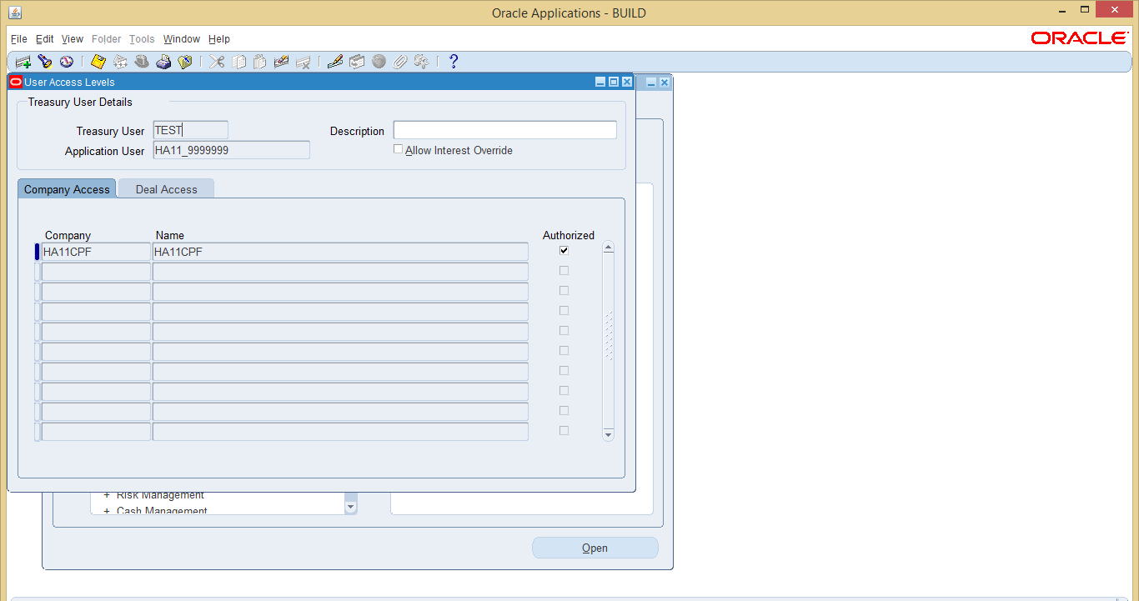

Important: You cannot access Treasury unless, you declare this user in the above setup.

Create New Counterparties

Use the Counterparty Profiles window to set up the internal and external counterparties that your company does business with. You cannot generate journal entries for counterparties.

Navigate to > Setup > Parties > Counterparties Profile

Query the counterparty that you wish to enter; this is to ensure that the counterparty does not already exists in the system.

Note: If you do not query the counterparty, the same counterparty will be created with two codes, which will lead to problems of duplicity.

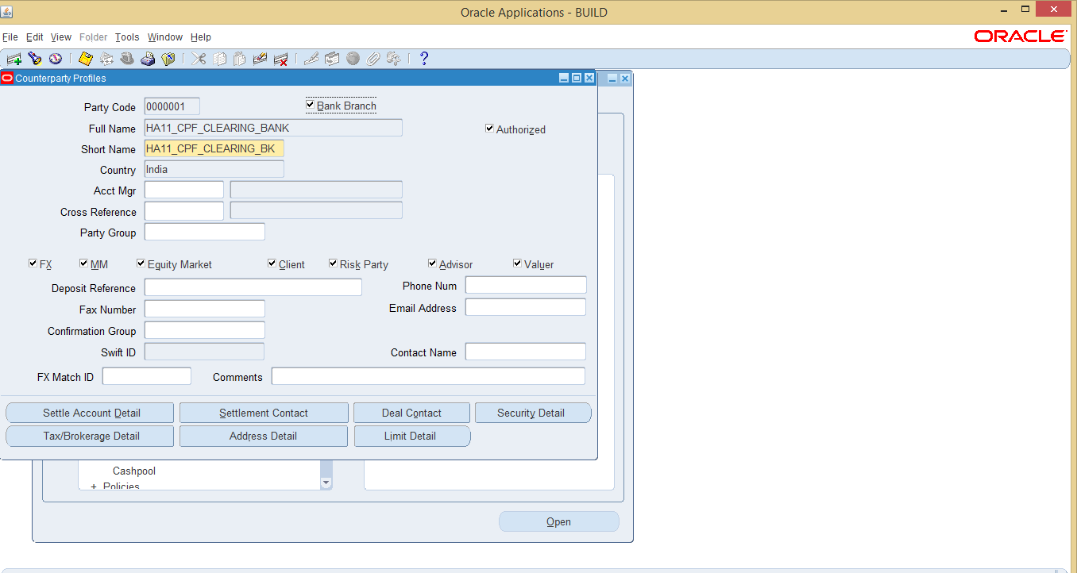

  - Enter the Party Code. The party code has a limit of seven characters.
  - Enter the Full Name.
  - Enter the Short Name. The maximum number of characters is twenty.
  - Counterparties need to be classified based on the type of deals that FCI will enter with them.
    - Click MM, if you want to enter into borrowing/investment deals with the counterparty. Bond deals will require MM to be ticked.
    - Click on Risk Party, in order to subscribe to issues of the counterparty. Classifying counterparty as risk party is prerequisite for setting up issues for that counterparty.
    - Click on ALL the check boxes, to allow any kind of deal to be entered for the Counterparty.

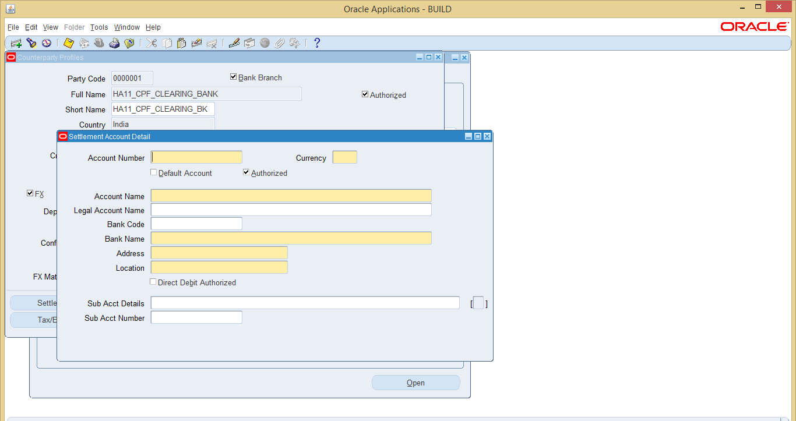

  - It is mandatory to give the bank account details of counterparties that are classified as FX, MM or Equity Market. Click on Settle Account Detail, to enter the Counterparty Bank account details. The bank account details of the counterparty will be useful for Electronic Fund Transfers. In case, the counterparties will be paid by check, define a dummy bank account.
    - Specify the Account Number, Currency, Account Name, Bank Code, Bank Name, Address and Location.

Even if you do not have the details of the Counterparty, as It is mandatory to give the bank account details of counterparties that are classified as FX, MM or Equity Market, specify Dummy account details.

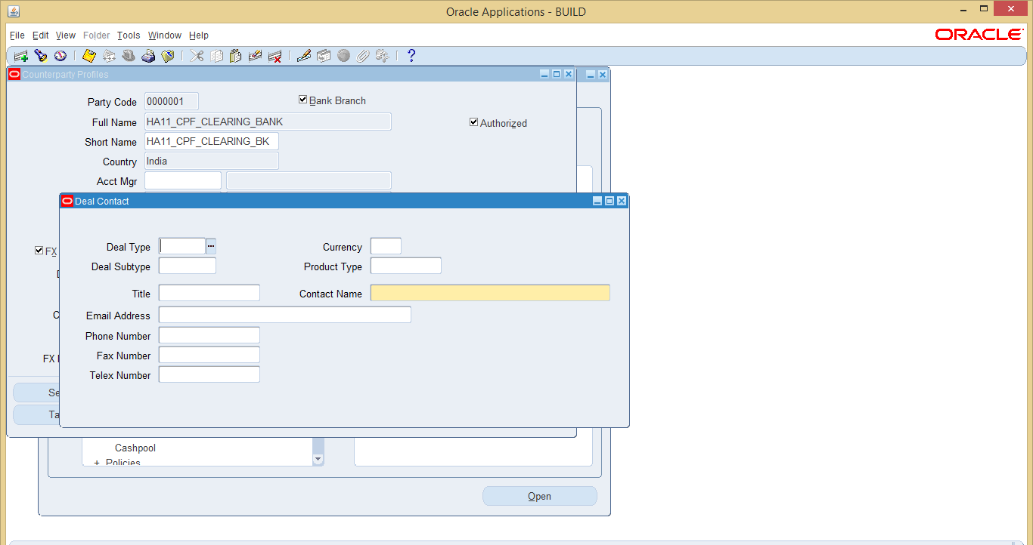

  - Optionally, you can enter the counterparty contact details in Deal Contact.

Enter New Company Profiles with Bank Account Details
A company is a party that initiates deals and that can run an in-house bank. You must
Create at least one company profile before you can begin using Treasury.

You can set up as many company profiles as you want. For example, if your company has a subsidiary and you want to track the treasury positions of that subsidiary, you can
also set up that subsidiary as a company.

A company profile associates your treasury department with a ledger. It also defines your
company bank accounts, the companies or counterparties who you grant debit
authority on your bank accounts, and your principle contacts.

Prerequisites
• Set up Legal Entities (In General Ledger)
• Set up Banks (In Oracle Cash Management)
• Set up Bank Branches (In Oracle Cash Management)
• Set up the banks that hold the accounts of your company as parties in the
Counterparty Profile window and link them to bank branches created in Cash
Management.
• Set up the currencies of your bank account.

Navigate to > Setup > Parties > Company Profiles

We only need to define the Clearing Bank for FCI and CPF.

The Bank Accounts in Treasury are maintained in the Bank Account Tab. As a Standard Operating Procedure (SOP), bank accounts should be first defined in Oracle Cash Management. First Create the Company with the header level information and then click on Bank Account Tab to enter the bank details :

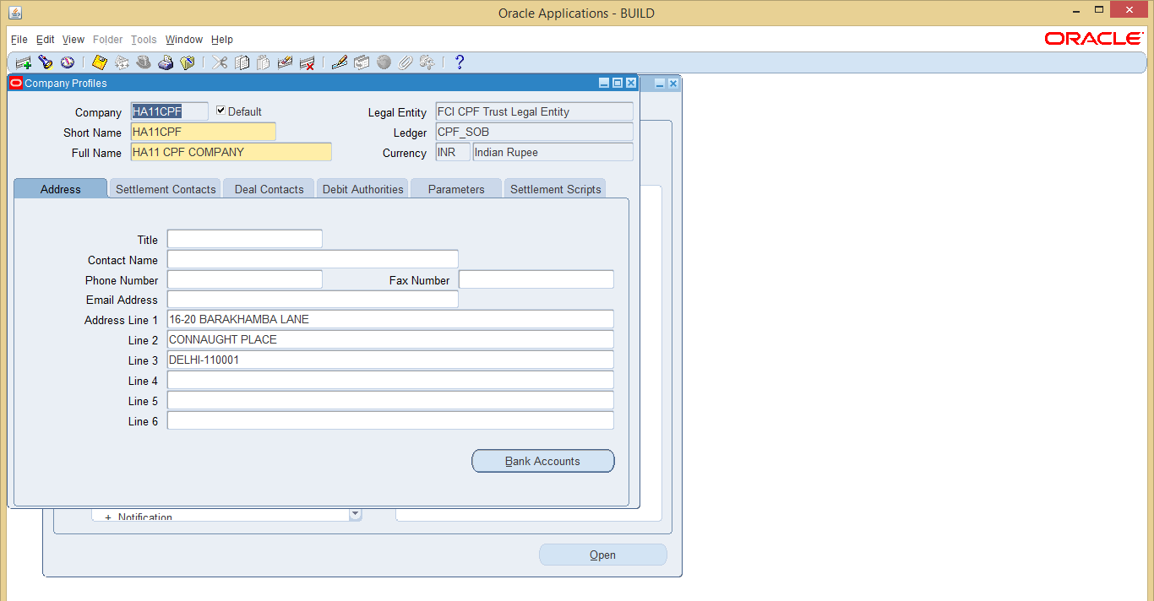

Note : Only the banks which are marked for usage in treasury in CPF SOB , will be available to be tagged in company profile.

On clicking Bank Accounts , a web page will be launched in explorer , you can search for the bank accounts in this page:

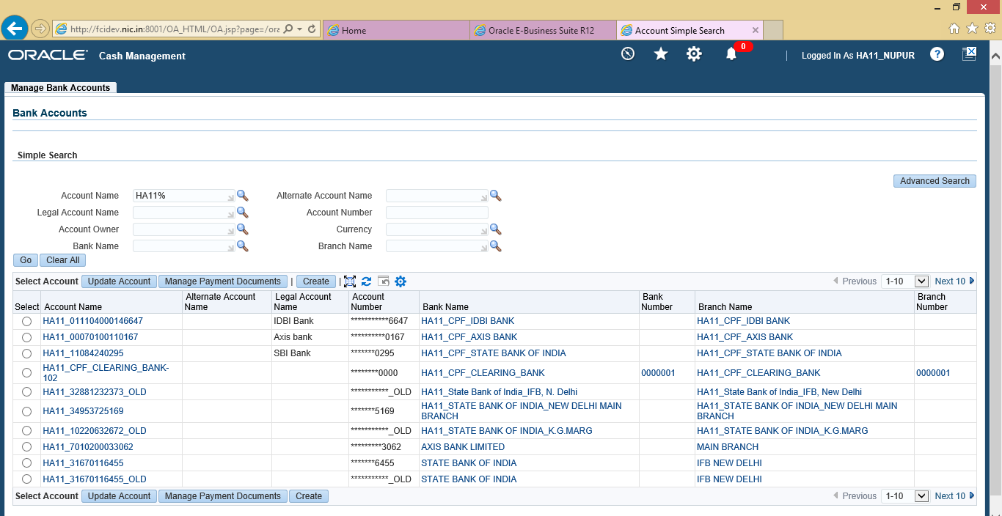

- Click on the account name you want to update for treasury.

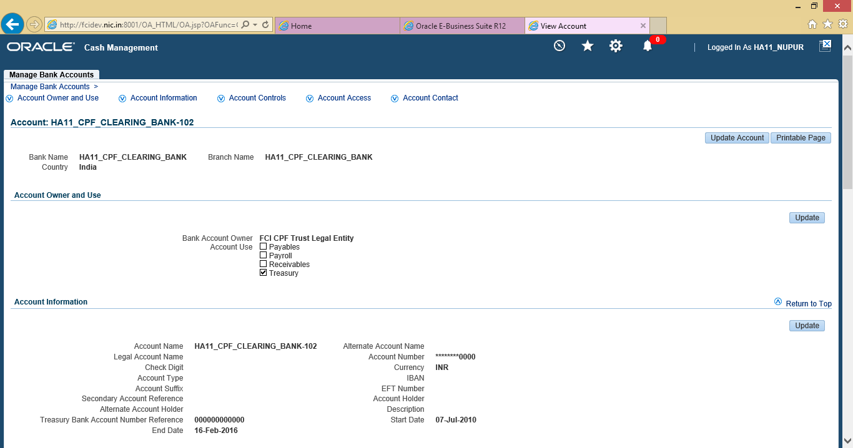

- Click on update and choose the account for use in treasury.
- Click on Next.
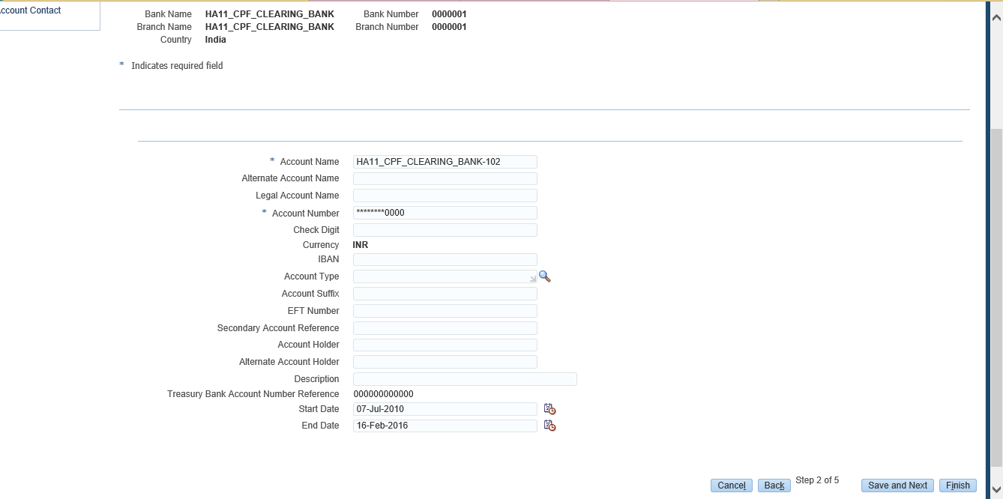

- Update any other bank account information you need to change, click on save and next.

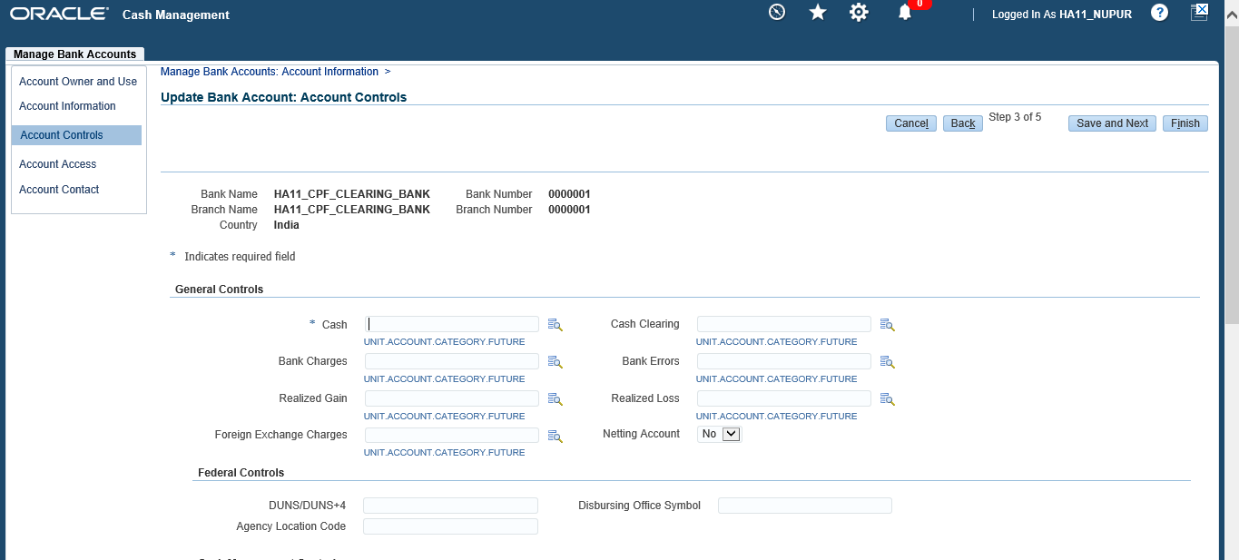

- Enter the code combination for the bank as required. Click on Save And Next.
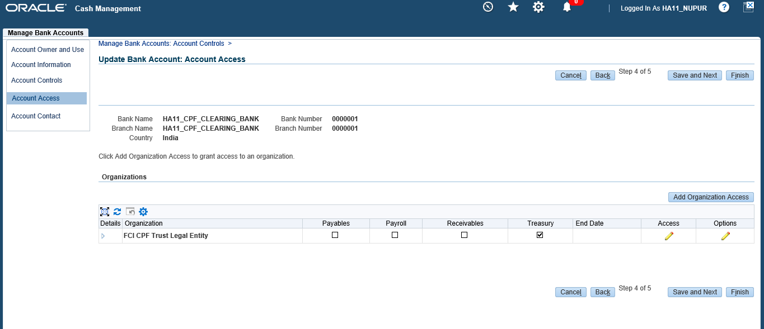

- Click on Access , it should be for treasury

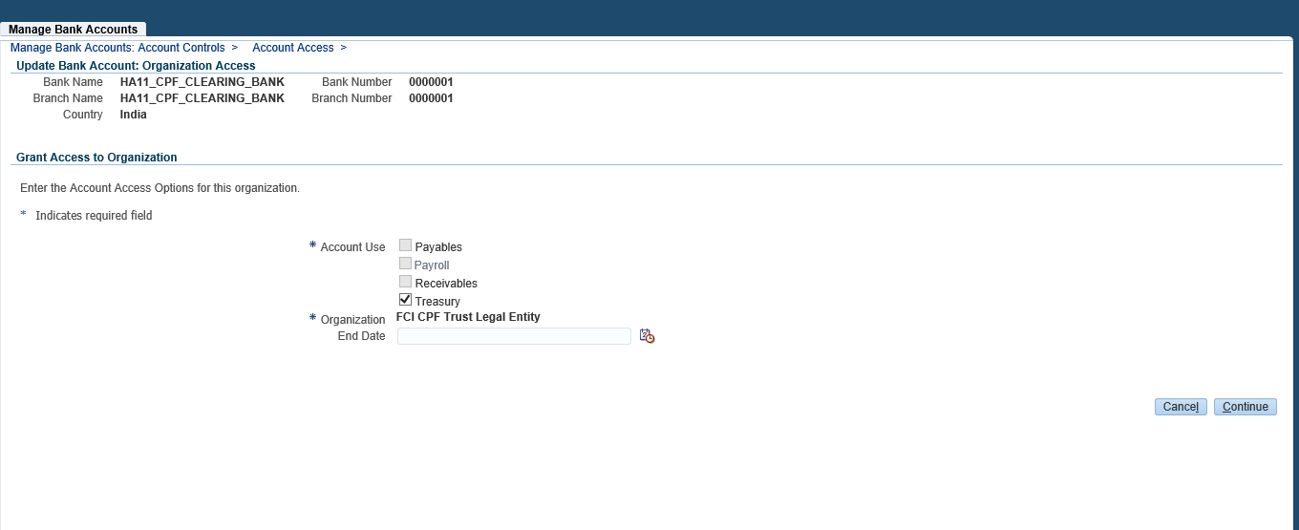

- Click on Continue, and then select Apply. You can finish the process here, but if you want to update the contact details also then click on Save and Next ,and create contact for your bank account.
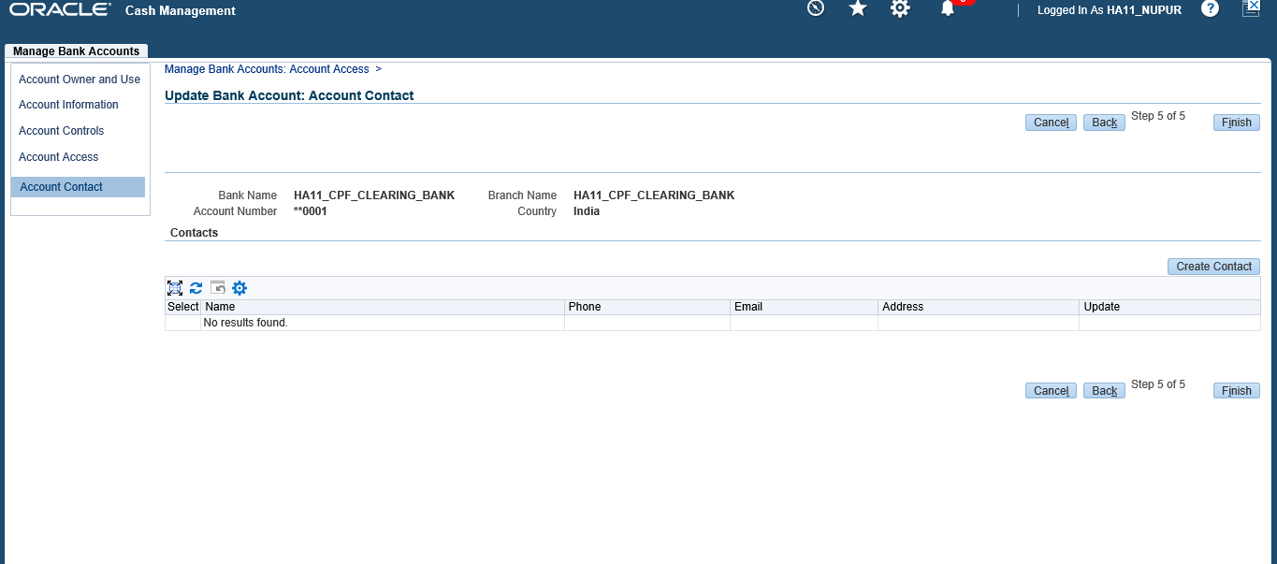
- After creating contact information, click on apply.
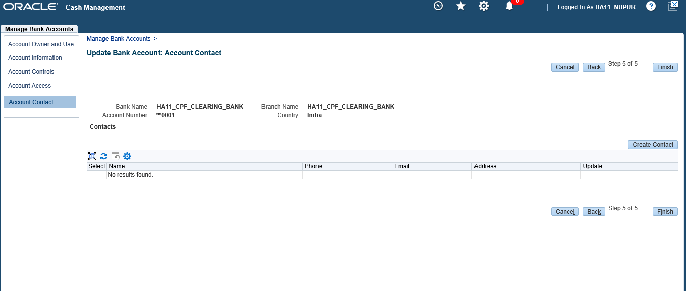

- Click on Finish, and the bank account update is completed.
Note: Before you can set up a company bank account, the bank that holds the bank account must be set up in Cash Management, a bank branch must be defined for this bank in Cash Management, and a counterparty must be set up in Treasury and linked to a bank branch in Cash Management. Otherwise, Treasury use check box will be disabled when you start creating a bank account in Cash Management.

Setup Currency Holidays

Navigate to > Setup > System > Currency Holiday Rules

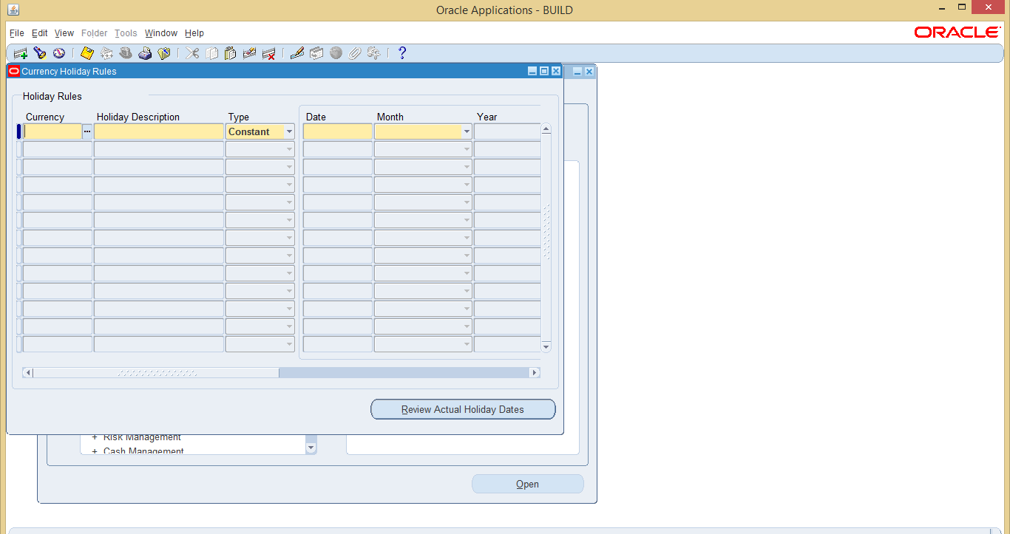

- Holidays which are Constants or Rules would have already been setup.
- Before the start of the year, you might have to enter the one-off type of Holidays.
- Enter the Currency, Holiday Description; Select the Type as One off.
- Enter the Date, Month and Year. Save the entry.

Navigate to > View > Request > Submit a New Request.
- “Position – Maturities by Date Report”. Specify the Holiday in the Period From and Period To. Click on OK.
If there are deals which have interest payment or Principal repayment on holiday, Go to the specific deal and change the maturity date to following or previous
- Run the report.

Issue Tradable Bonds
Bond issues are used to record static information for long-term securities, such as Government bonds, that your company invests in or issues. You must set up a bond
Issue before you can enter a deal for that bond.

Navigate to > Setup > Deals > Bond Issue

- Bond Issue needs to be setup first, before issuing Bonds

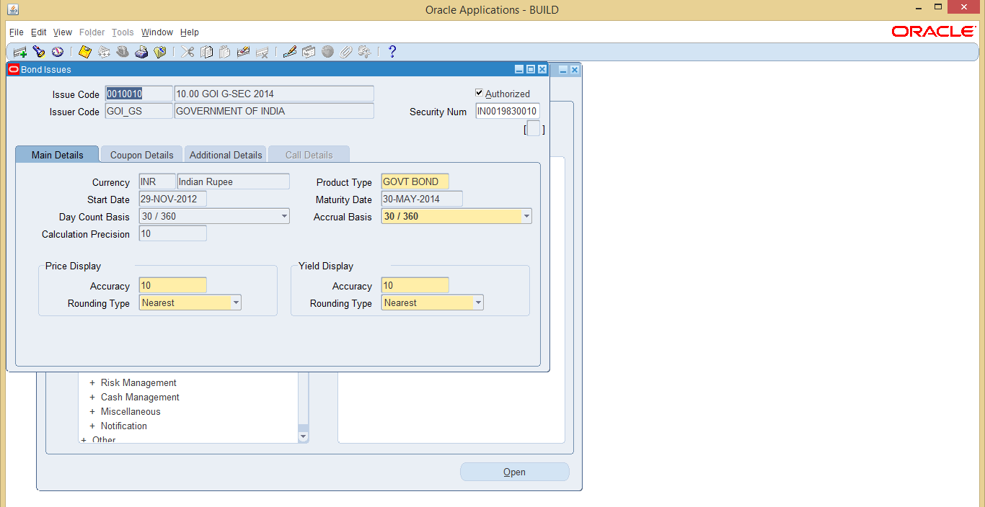

- To setup the Bond Issue, the user will need to provide details like Issue Code, Issuer Code (in case FCI in issuing the bonds the Issuer will be FCI), Currency, Product Type, Start Date, Maturity Date. The Bond Issue will have to be authorized.

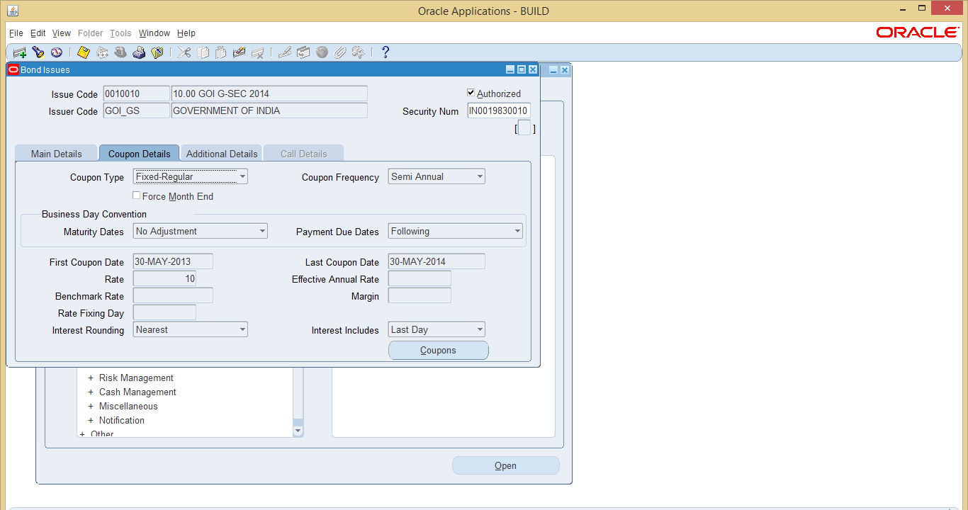

- The Coupon Details of the Bond need to be specified, Select the appropriate Coupon Type
  - Fixed Irregular – Select this coupon type if the interest is fixed till maturity and it is to be calculated for actual number of days. E.g. If the interest is to be calculated for a period of say 252, select the coupon type as Fixed-Irregular.
  - Fixed Regular – Select this coupon type if the interest is fixed till maturity and it is to be calculated assuming 365 days in a year(semiannual interest will be calculated for 182.5 days) irrespective of the actual number of days in the interest period.
  - Floating –Regular and Floating Irregular can be used in case the interest rate is floating

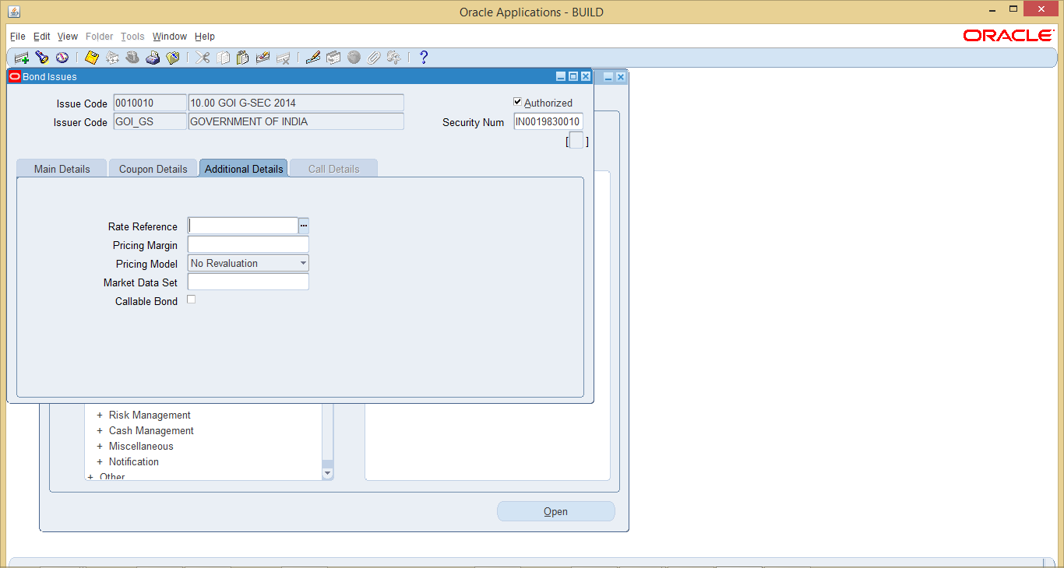

- If the bonds are callable, please check the Callable Bond tab.

- In case of callable bonds, please specify the Notification Date (the date by which the holder needs to be told in call the call option is to be exercised), Call Date and the Price in the call details tab

Deal Creation
A fixed income security is a long term tradable instrument that pays a regular coupon or Interest at a fixed rate. Such securities are commonly called bonds, and include Government stocks, and corporate bonds.

Navigate to >Money Market Transactions > Negotiable Instruments> Fixed Income Securities

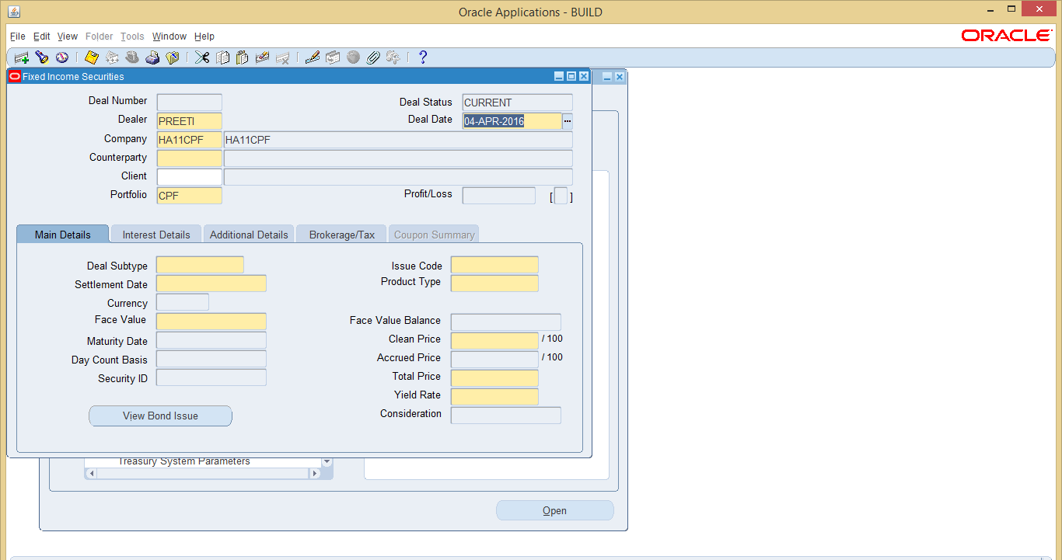

- Create a Deal based on the Bond Issue Code setup in Step 1 to 5. Specify the Deal Date, Counterparty, and Portfolio, Specify the Deal Subtype as ISSUE, select the issue code that has been setup in Bond Issue, the Settlement Date is the Bond Issue date.

- The Face value of the bond is the Total Issue size, specify the Clean Price as 100.

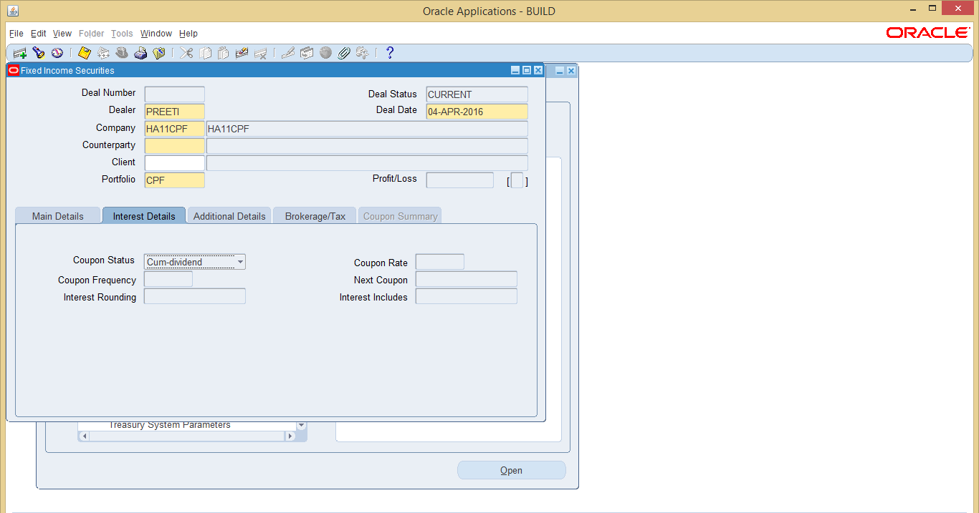

- The Interest Details will default from the Bond Issue setup.

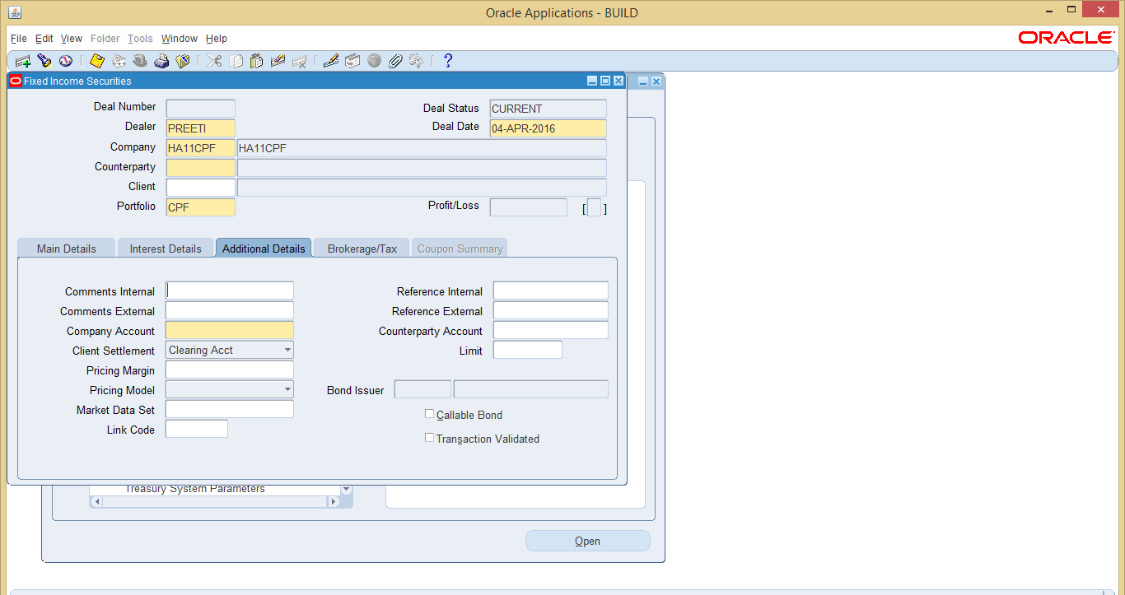

- Specify the Company Account. Save the Deal.

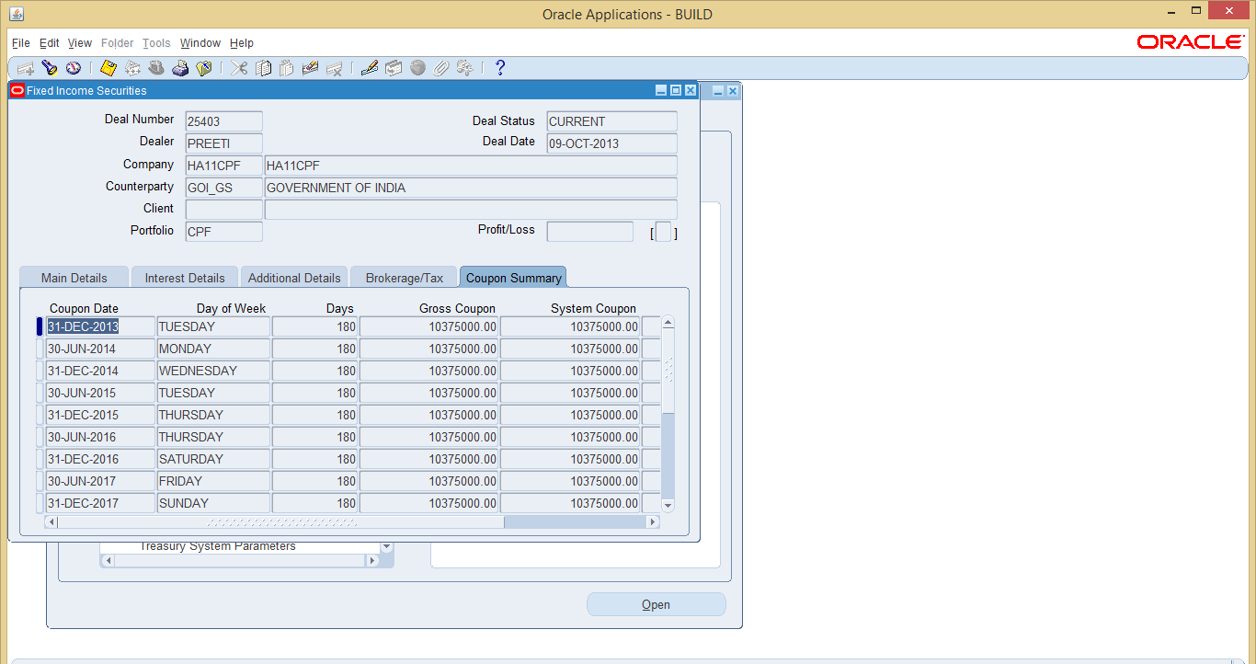

- Review the Coupon Summary.

- Validate and Settle the Deal.

Validation in Treasury
You should validate your deal transactions before settling them. Validating your Transactions is mandatory or else the interest deals will not pass on general ledger.

Navigate to > Settlements > Transaction Validation

  - To find the un-validated deals, click on Not Yet Validated option

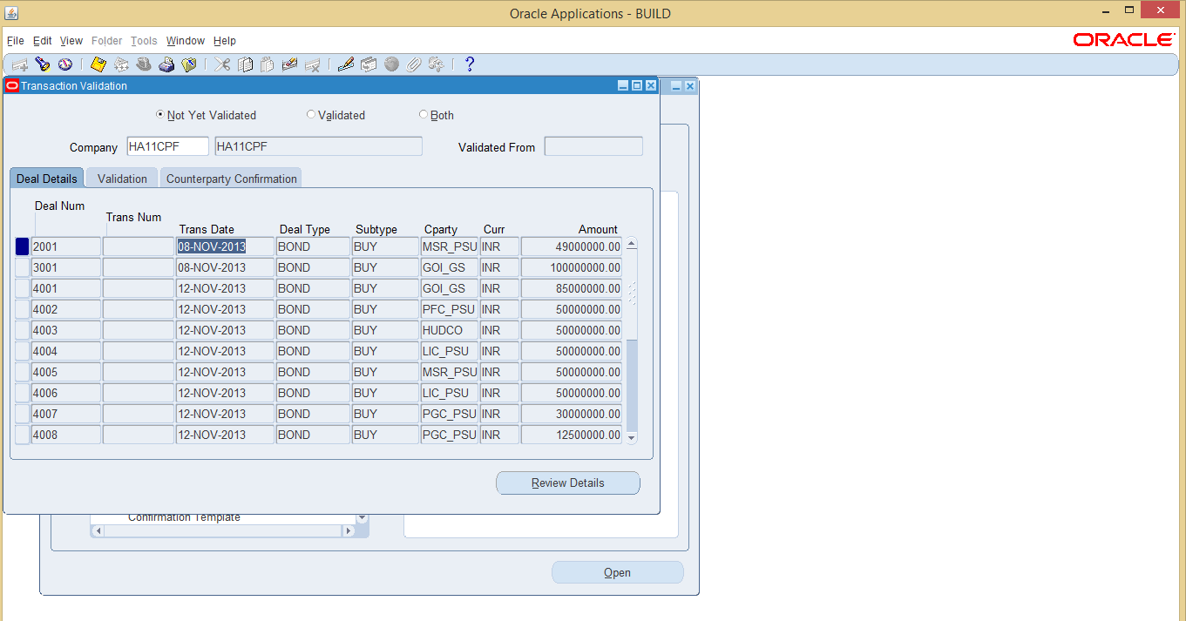

  - Click on review details and then check the options of Transaction Validated, and save the transaction. Deal will be validated then after.

Other way to validate a deal is:

Navigate to: Settlements >> Settlements

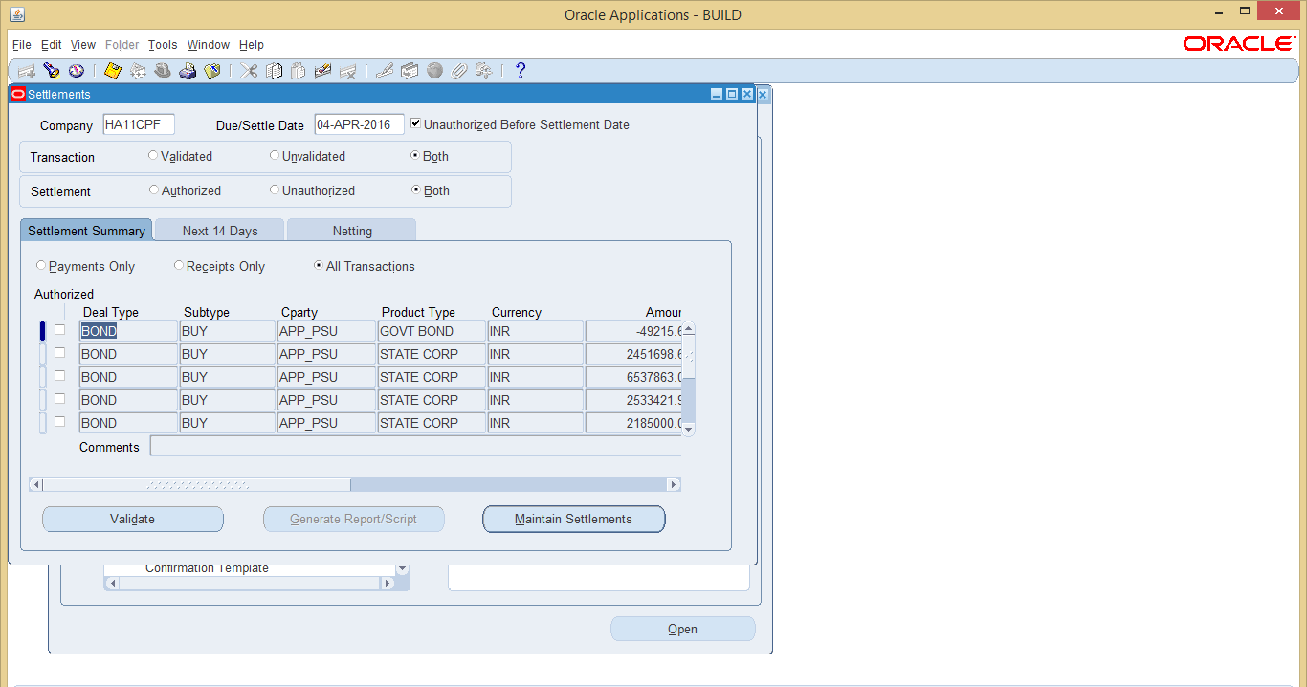

Steps:
- Validate the transaction
- Authorize the transaction
After creating any deal, user will have to settle it for the first time from the above screen.

Create Accounting
The Treasury accounting process creates company journal entries and transfers journal entries from Treasury to General Ledger.

Navigate To: View Requests >> Submit a New Request>> Program - Accounting Streamline Processing

Steps:
- Submit the request with the required parameters.
- This program submits the request. In FCI, the process starts from accrual and can stop at either Generation OR at transfer to GL. It is recommended to stop the process at Generation, review the journal entries and then transfer the same to GL.
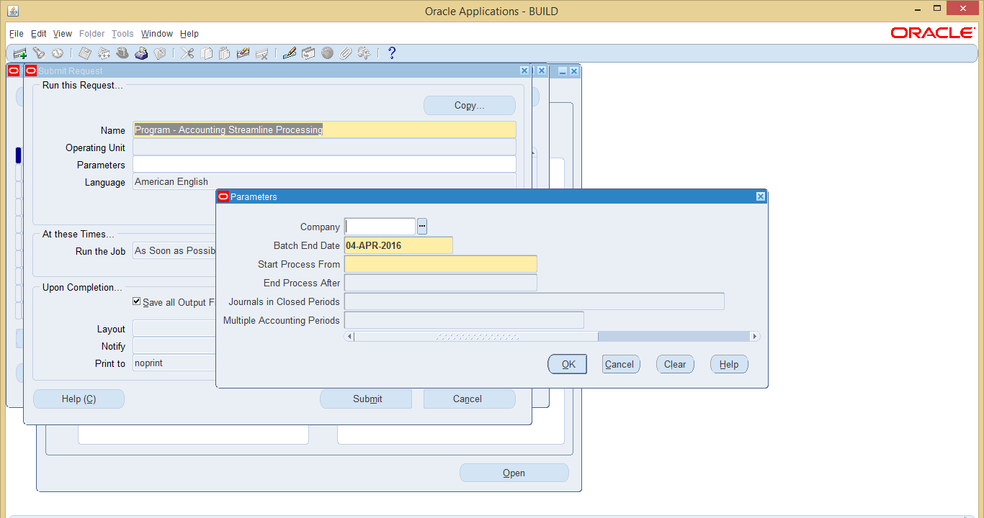
As discussion with GMFAP, this program has been disabled currently, and could not be submitted by the user.

Or the other way is Navigate to Accounting Accrual:

- Click on Calculate to generate the accrual for all the deals.

- User can select the period for which accrual is to be generated.

- On clicking the calculate tab, it will submit a program: Program - Generate Accruals

- When this request is completed normally, it will generate the accrual details.

- User can select the batch id then view the details and then authorize it.

- Once the accrual details are authorized, user can generate the daily journals for an accounting batch, view the generated journal entries through the Daily Journals window.

Note: If user has generated the daily journals, then user cannot unauthorized the accruals.

- User can delete period adjustments for a batch until user has transferred the daily journals for the batch to General Ledger.
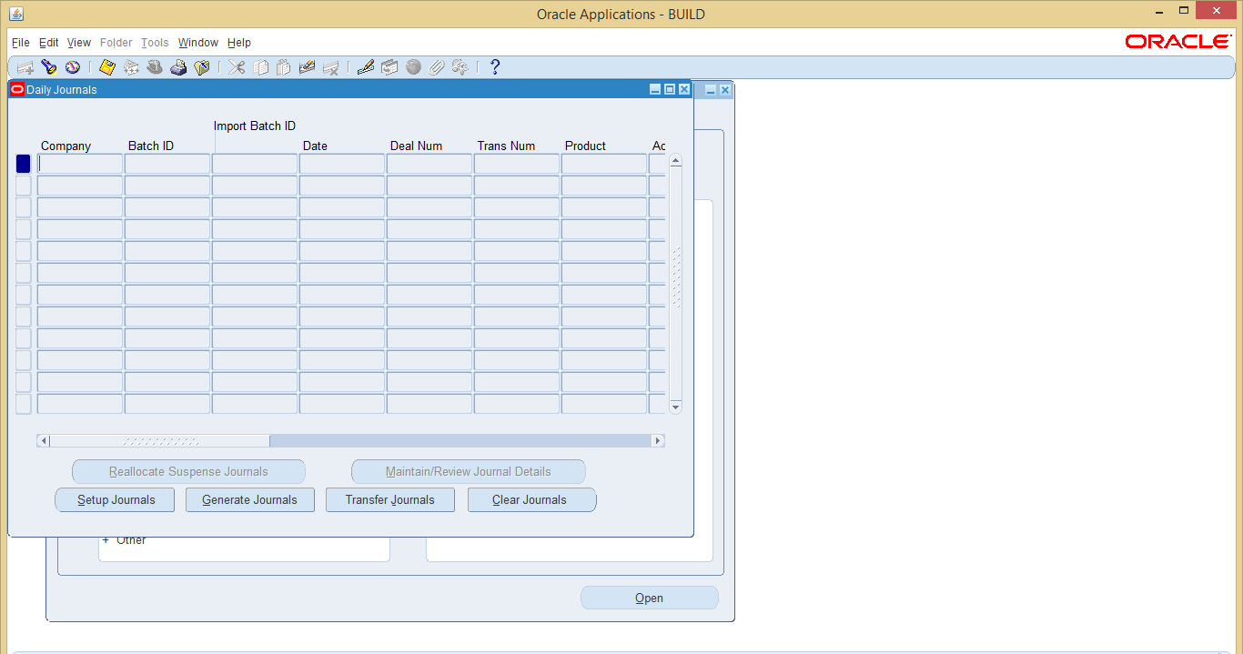

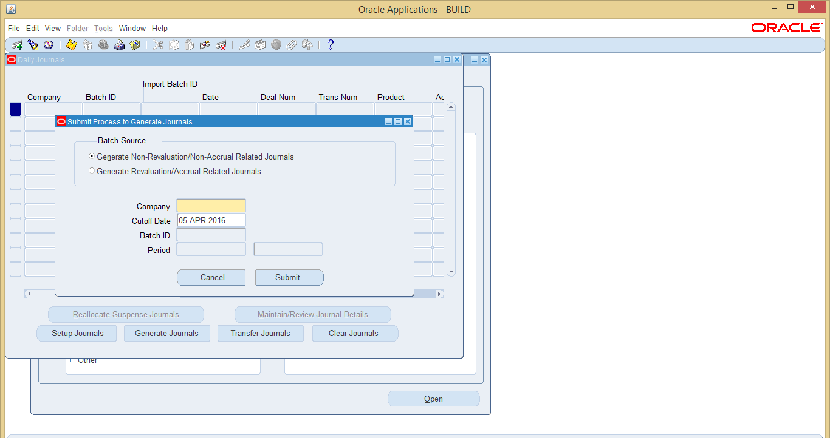

If user has authorized the accrual details then select the batch source as: Generate Revaluation/Accrual related Journals or else select Generate Non-Revaluation/Non-Accrual Related Journal.

Generate Non-Revaluation/Non-Accrual Related Journals:

To generate journals user has to give the cutoff date, that is the date till which user wants to generate the daily journals.
Once the user submit the request: Program - Non-Revaluation/Non-Accrual Related Journal processing it will submitted. When this request is completed normally, user can view the journals

Generate Revaluation/Accrual related Journals:
Use the Daily Journals window to generate daily journal entries for an accounting batch. Daily journals are generated based on the deals in the accounting batch and the journal entry actions that you set up in the Journal Entry Actions window.

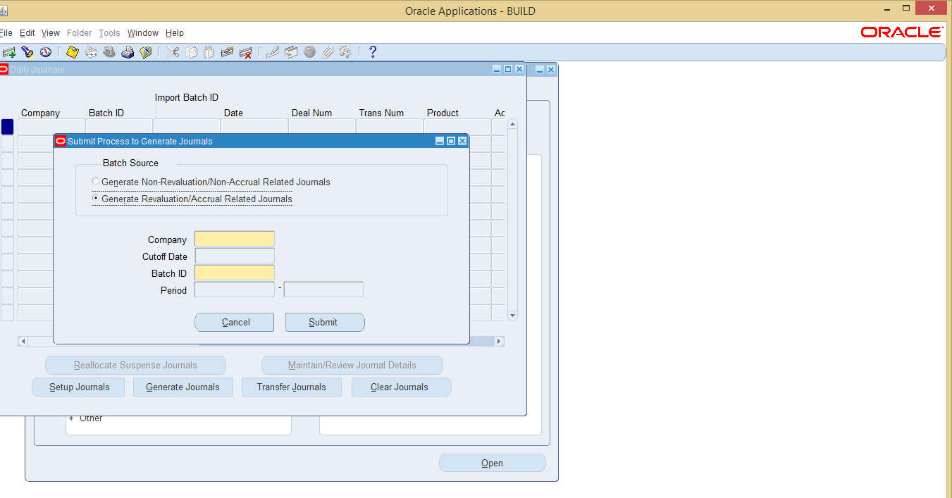

In this user has to provide the batch id of the accruals. If the batch is authorized then only it will be reflected in the LOV.

Once the user submit the request: Program - Revaluation/Accrual Related Journal Processing it will submitted. When this request is completed normally, user can view the journals.

In case there is any discrepancy in the journals, user has to clear Journals then make the necessary corrections and then again follow the steps to generate journals.
After user has verified all accounting changes for the journal, use the Transfer Journals to GL window to transfer the journals from Treasury to General Ledger. Once user has transferred the daily journals to General Ledger, user cannot change any of the accounting for the batch in Treasury.
NOTE: Sunday is considered as holiday in treasury setup. Any coupon fall on Sunday will be reflected on Monday in respect of accounting. Deals will be not entered on Saturday and should be taken care by users manually.

View Journal Entries

Navigate To: Accounting >> Daily Journals

Steps:
- Query on the required Journal. The Journal entries will be visible as seen below.
- The file can be viewed as excel, in the same manner as other excel files. Details of the procedure to take the data to excel are explained in Go Live Criteria Document.

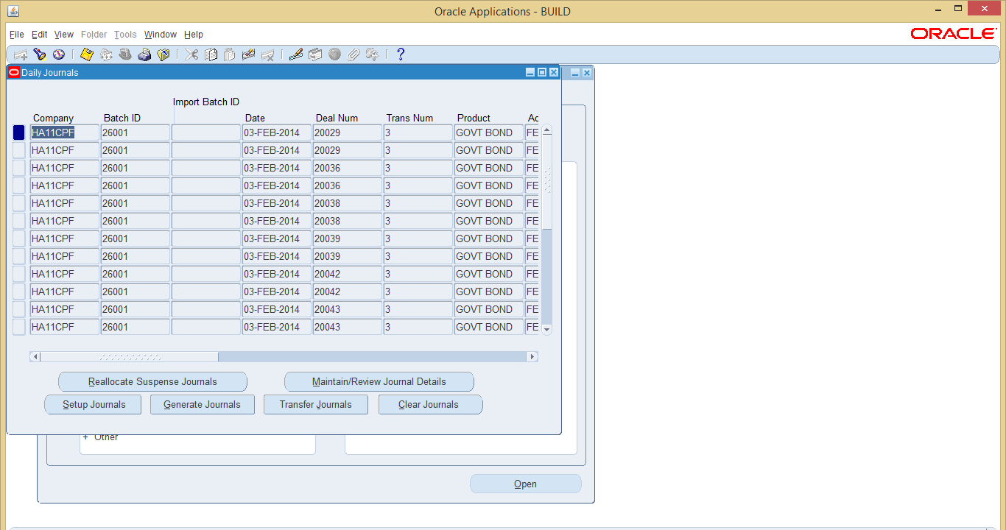

- Export to Excel: On opening the Journal, click the first line of the Journal entry and export the file to Excel by clicking on the file menu and then export. IMPORTANT: Please keep the control key pressed while exporting to excel.
- Continue to End: If you get a message box, press continue to end to continue exporting. System will start exporting data.
- Save the TSV: The file format is of the type tsv, save it in the requisite folder. The file can be changed to WA11_TB_EXPORT.tsv.
- Convert the tsv to xls: Open Microsoft excel and open the csv. Please ensure that the file type at the bottom is all files or else the files with the type csv will not be seen.
- Type Delimited: Select the type as delimited.
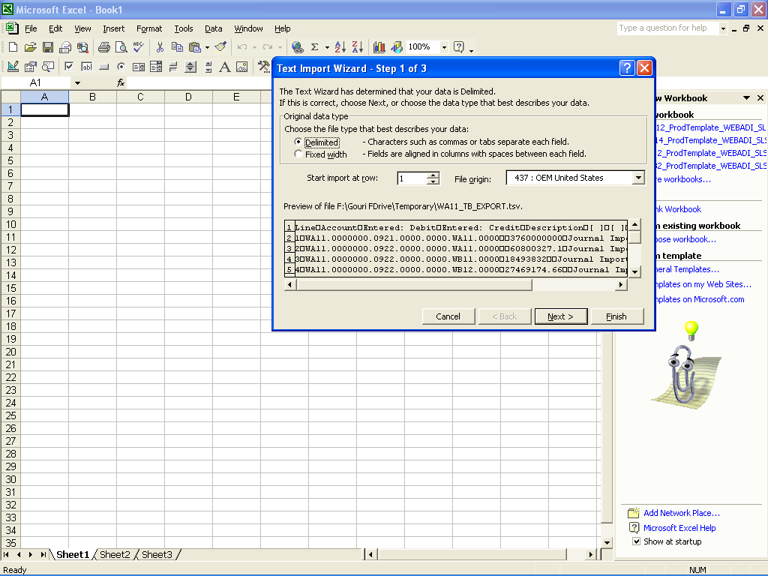

- Complete the tsv to excel conversion: Click on next to complete the conversion to excel.
- Save as Excel: Save the document as excel.

Transfer to GL
After successfully completing all of the steps in the accounting process, transfer your daily journal batches to General Ledger. Before you perform this step, you must ensure that you have entered and verified all accounting changes. Once a journal is transferred to General Ledger you cannot make any further changes. If a deal changes after you transfer to GL, you must create a reversal and a replacement journal.

Navigate To: Accounting >> Daily Journals

Steps:
- Navigate to the form
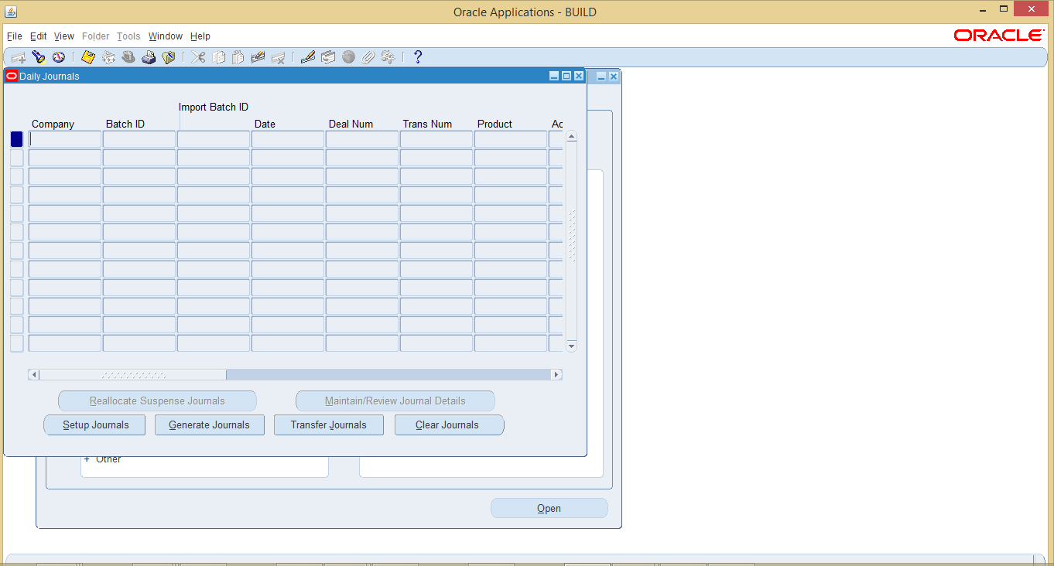

- Query on the required Journal. The Journal entries will be visible as seen below.

- Click on Generate Journals to generate accounting for the journal of deals.
- For Transferring these deals to GL, click on transfer journals, which will create corresponding journals in GL.

Brokerage in Treasury

This section contains information on how to set up the default tax and brokerage rates as well as the tax and brokerage schedules that apply to your deals. It also contains information on how to apply these schedules to your counterparties, and how to set up settlement accounts for your brokerage fees and taxes.

Navigate to >> Brokerage Schedules And Creation

Pre-requisite:
Define a counterparty as a Risk Party in the Counterparty Profiles window

Through this functionality user can define a particular slab of brokerage , which includes the rate at which commission is charged by the broker.

Once the set-up is defined, it has to be assigned to a particular counter party, so that it can act as a broker with pre-defined charges.
Process has been described briefly below:

- Enter a rate group and the range of brokerage rate to be setup on amount.

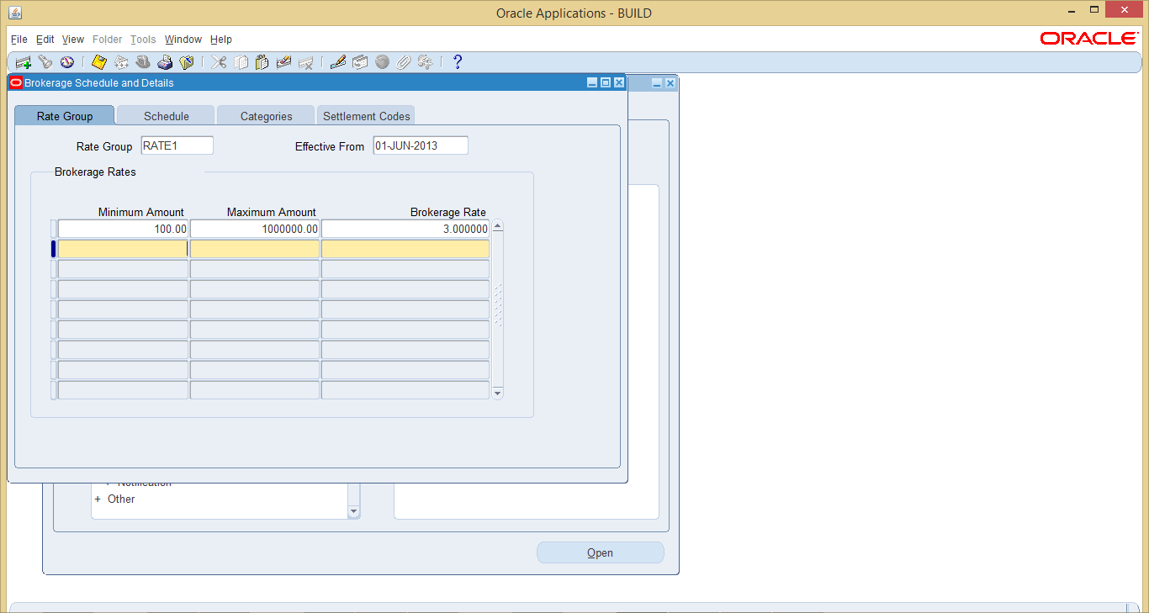

- Describe a schedule for the rate defined.
  - In the Schedule field of the Schedule tabbed region, enter a unique code for the
Brokerage schedule.
  - In the Rate Group field, select a rate group.
  - In the Payee field, select the counterparty that is going to receive the brokerage fee.
  - In the Deal Type field, select the deal type that you want to calculate the brokerage fee for.
  - In the Calculation Type field, select the calculation type that you want to use to
Calculate the brokerage fee.
  - In the Applicable Amount field, enter the amount of the deal that the brokerage fee is applicable to (for example, 1,000,000.00).
  - To authorize this schedule for use, check the Authorized check box.
  - Save your work.
Note: The list of available calculation types differs depending on which deal type you selected. For example, for equity deals, you can only select Consideration - Flat Basis.
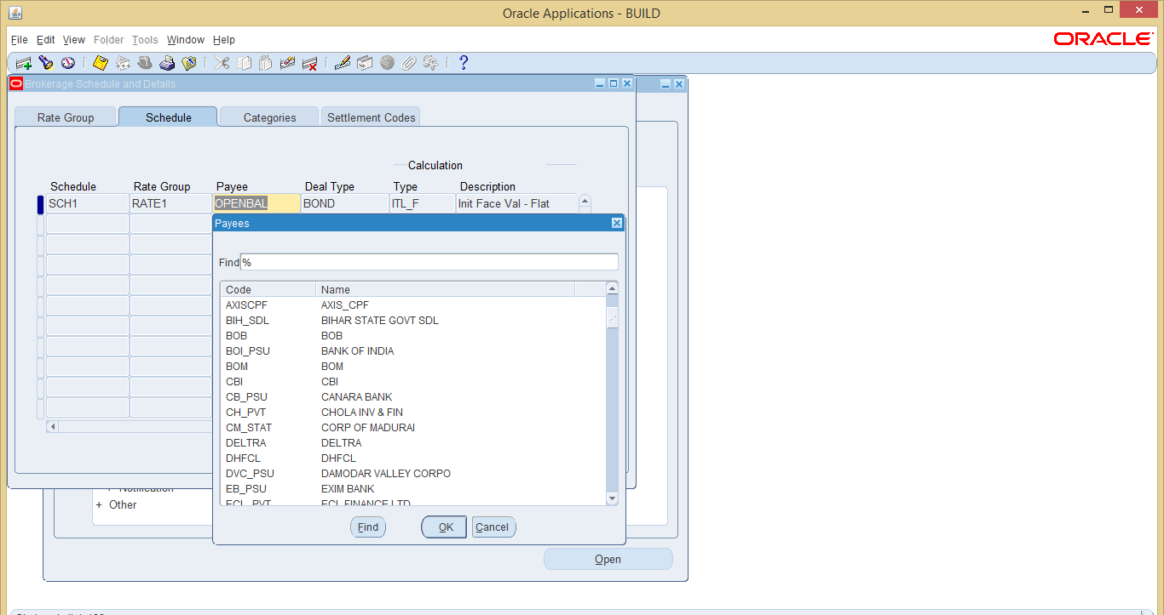

- Again, define a category and assign this rate and schedule to the deal subtype with which you want to use brokerage.
  - In the Category and Description fields of the Category tabbed region, enter a unique brokerage category code and description.
  - For each brokerage category that you define, in the Brokerage Details region do the following:
    - In the Deal Type field, choose the deal type that you want to define a default brokerage schedule for.
    - In the Schedule field, choose the default brokerage schedule for the deal type.
    - If you want the brokerage schedule to apply to a particular combination of deal subtype, product type, or counterparty, complete those fields as necessary.
  - Save your work.
  - To allocate a brokerage category to one or more counterparties, do the following:
    - Choose the Allocate to Cparties button. The Counterparty Profiles window appears.
    - Query the counterparty that you want to assign the brokerage category to.
    - Choose the Tax/Brokerage Detail button. The Tax/Brokerage Details window appears.
    - In the Categories Brokerage field, choose the brokerage category. You can override this default brokerage category during deal input.
  - Save your work.

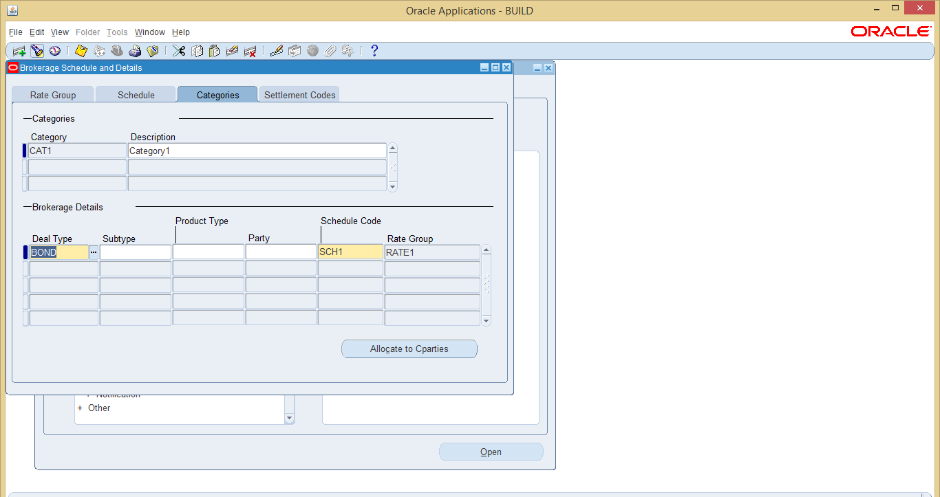

- Define a settlement code.

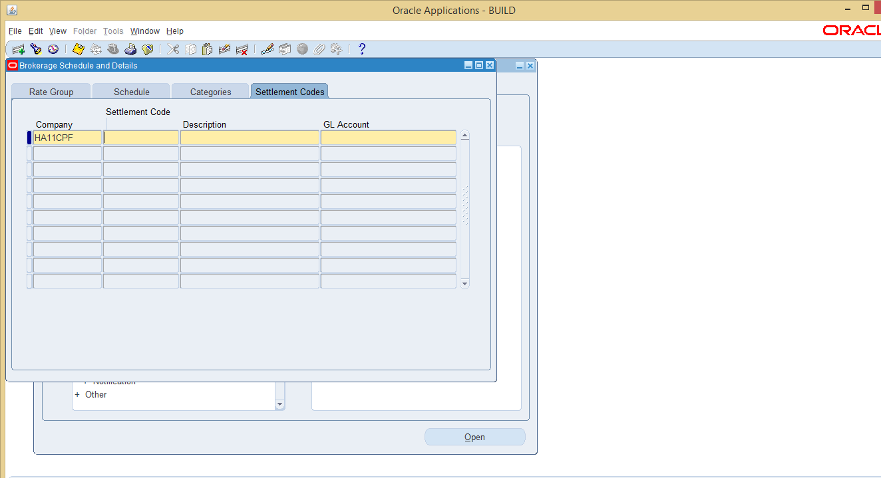

- Now assign this brokerage setup with the counterparties which are playing broker’s role.
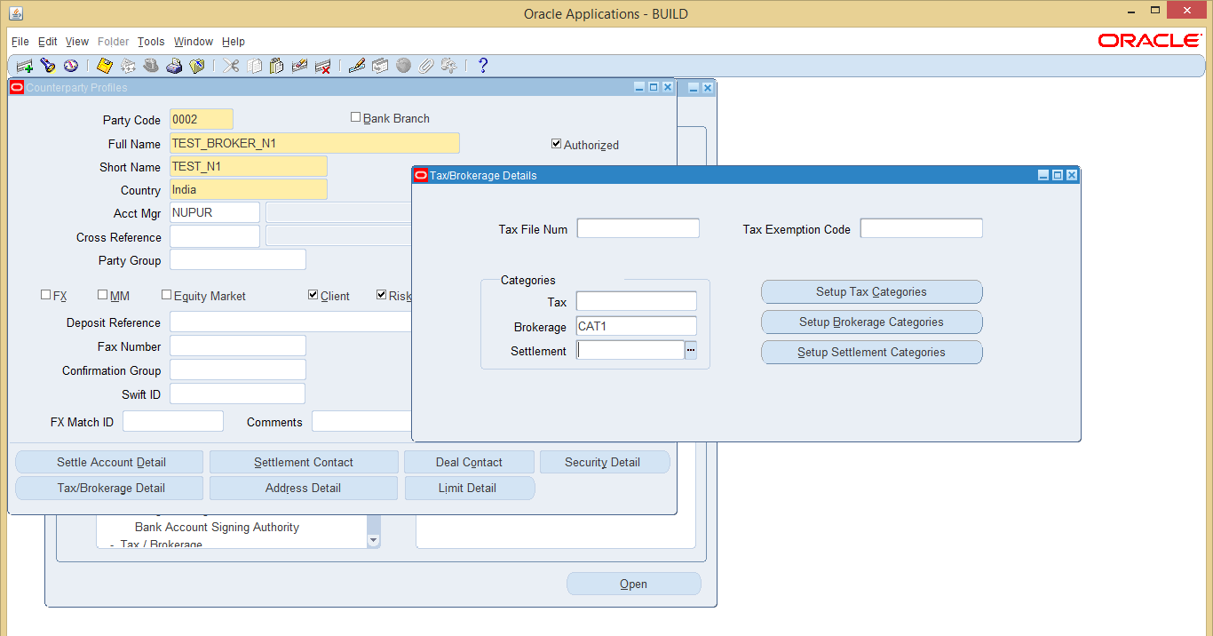

- Now while making a deal, we can use the broker as client .Thus its brokerage will automatically be calculated.

Navigate to the path settlement>>Tax/Brokerage Settlement to settle the brokerage

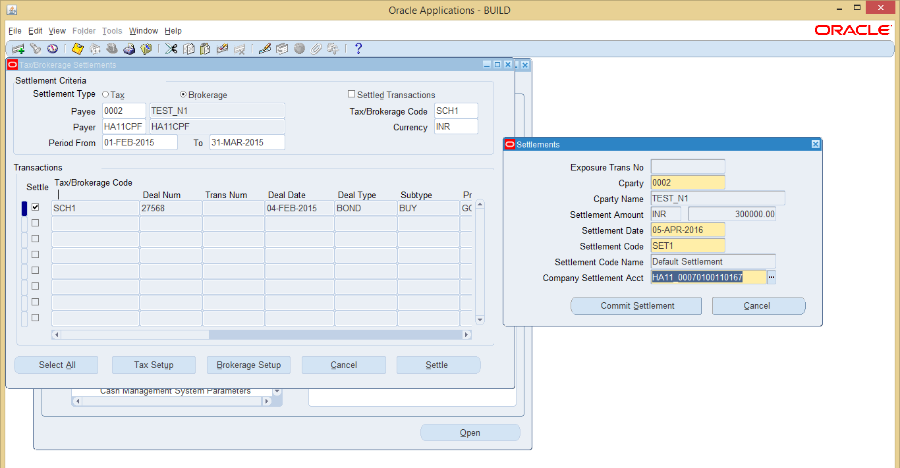

After confirming the settlement, we have to authorize the settlement by navigating to the path Settlements, as described above.

Reports in Treasury
Bond Register
This is a discoverer report which fetches details of a bond, as in the parameters.
The parameters required for this report are as follows:

Parameter Name | Optional/Required | Description
Company | Required | Company for which the report has to be executed
Product Type | Required | Product or Bond name
Deal Type | Required | Type of Deal for which report has to be executed
Issue Code | Required | Issuing Code
Holding Date | Required | Period till which report has to be executed.

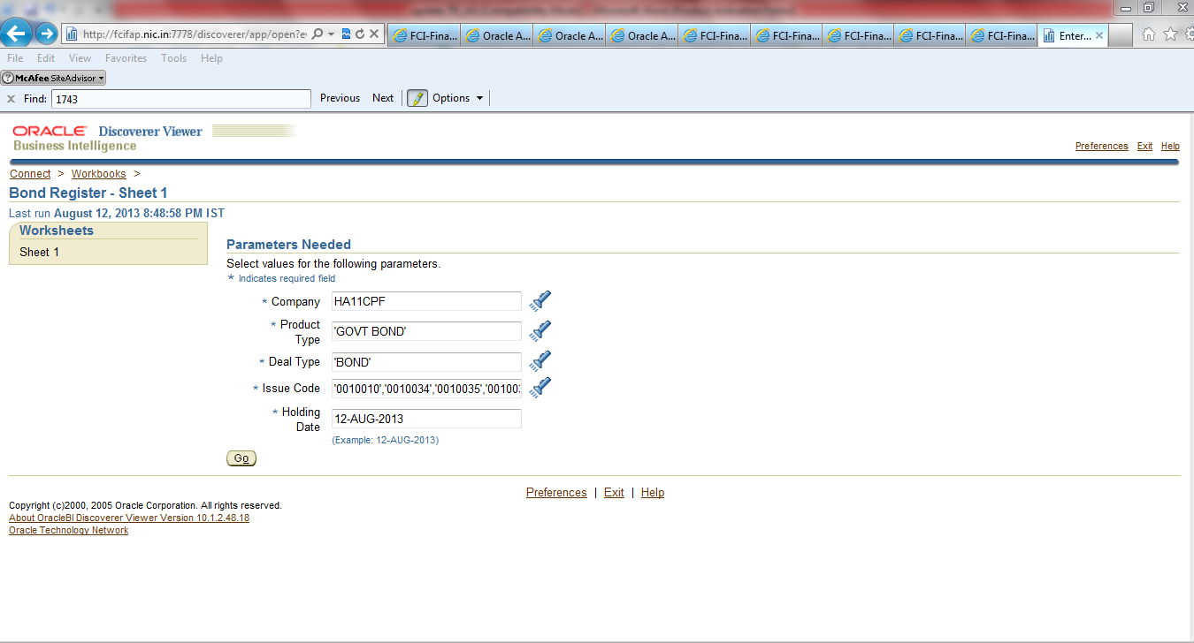

The output of this report as follows

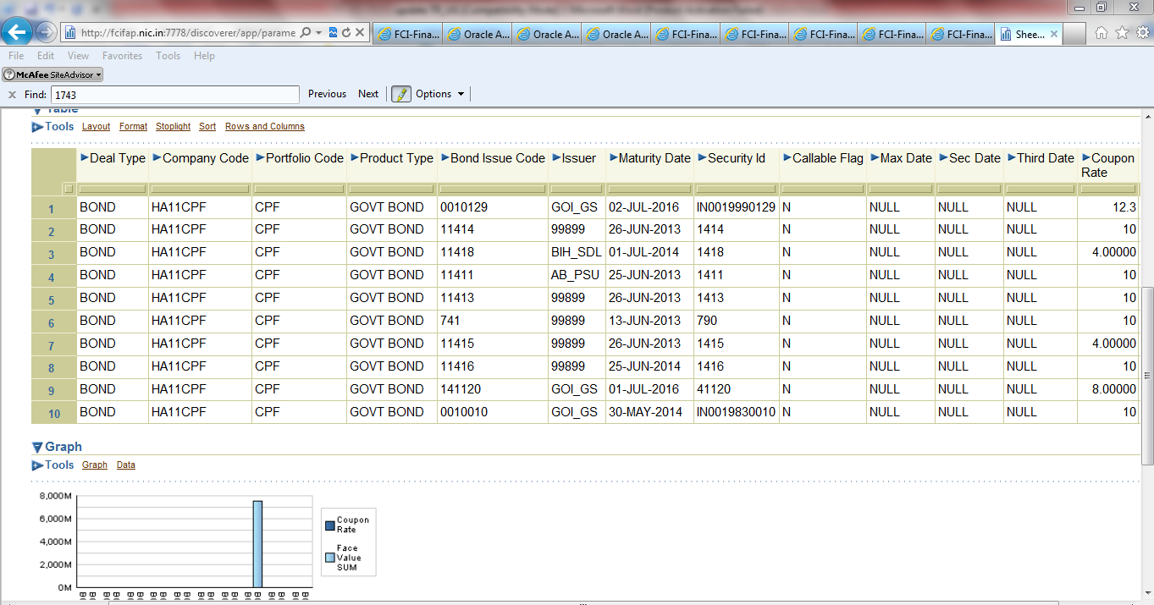

The output can be fetched in .csv format using the Export option provided. Sample output is attached below:
FCI CPF Deal Register
This is an XML report which will fetch data for deals falling in the period for which report has been executed. It can be executed for a particular period range, and will bring all the details of a Deal including Purchase price, Maturity date, Interest received, due interest accrued etc.

The parameters of the report are described below:

Parameter Name | Optional/Required | Description
Start Period | Optional | Starting period for which the report has to be executed.
End Period | Required | Ending period till which the report has to be executed.

If start period is given as null, report will fetch data on the basis of end period (assuming it as ‘As on Date’ ). For instance, if start period is null, and end period is given as MAR13-14, then the report will fetch data from starting of financial year (APR-13) till MAR-14.

Snapshot of request is attached below:
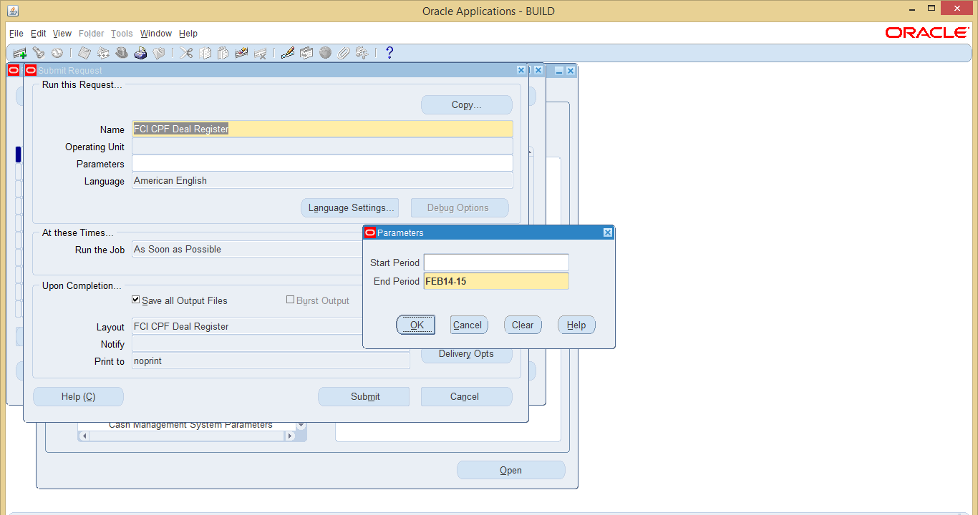

Output for reference is attached below:

Fixed Income Securities Redemption
This is a discoverer report which brings data of bonds and bond issues, along with the issuer name and other details of bond. It is a discoverer report, and if two transactions exist for the same bond product type, then in place of two separate lines, one record with total sum amount will be reflected.

The parameters for the report are described below:

Parameter Name | Optional/Required | Description
From Date | Required | Starting period from which the report has to be executed.
To Date | Required | Ending period till which report has to be executed.
Deal Type | Required | Type of Deal for which report has to be executed
Product Type | Required | Product or Bond name
Company | Required | Company for which the report has to be executed
Bond Issue | Required | Issuing Code

Snapshot is attached below for reference:

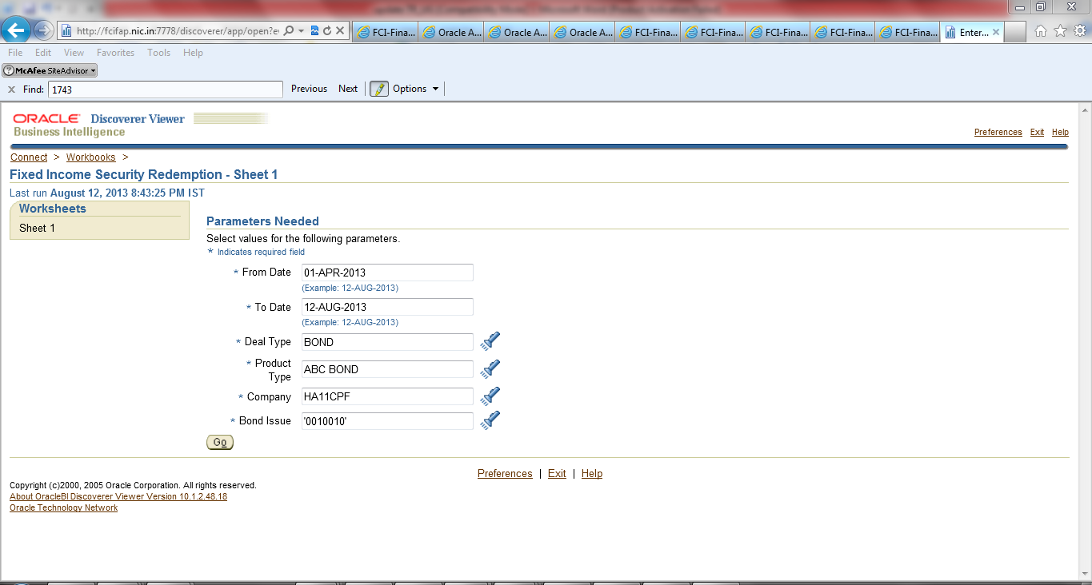

The output is attached below:

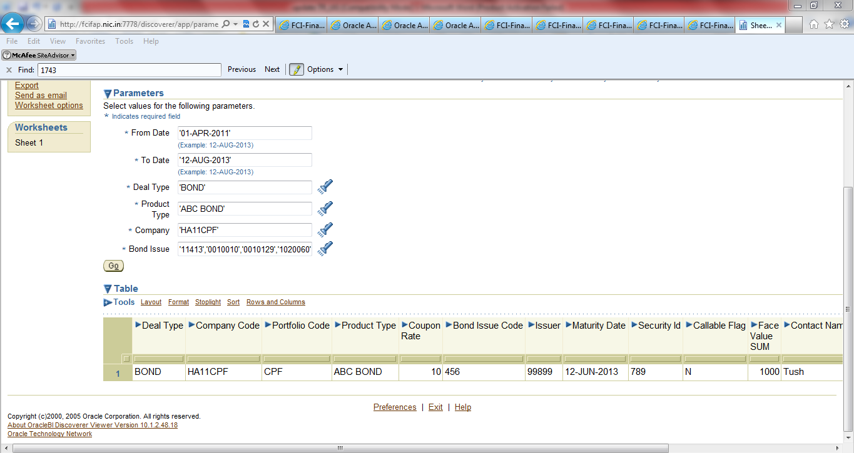

The output can be fetched in .csv format using the Export option provided. Sample output is attached below:

FCI Bond Maturity Report
This is an XML report which fetches the detail of bonds which are getting matured in the specified period in excel format.
The report can be executed for a particular period, and the output will fetch details of premium / discounts amounts that is to be amortized, in that period.

Parameter details are given below:

Parameter Name | Optional/Required | Description
From Date | Required | Starting period for which the report has to be executed. It can be a maximum of current date.
To Date | Required | Ending period till which the report has to be executed.

Screenshots of execution of report are attached below
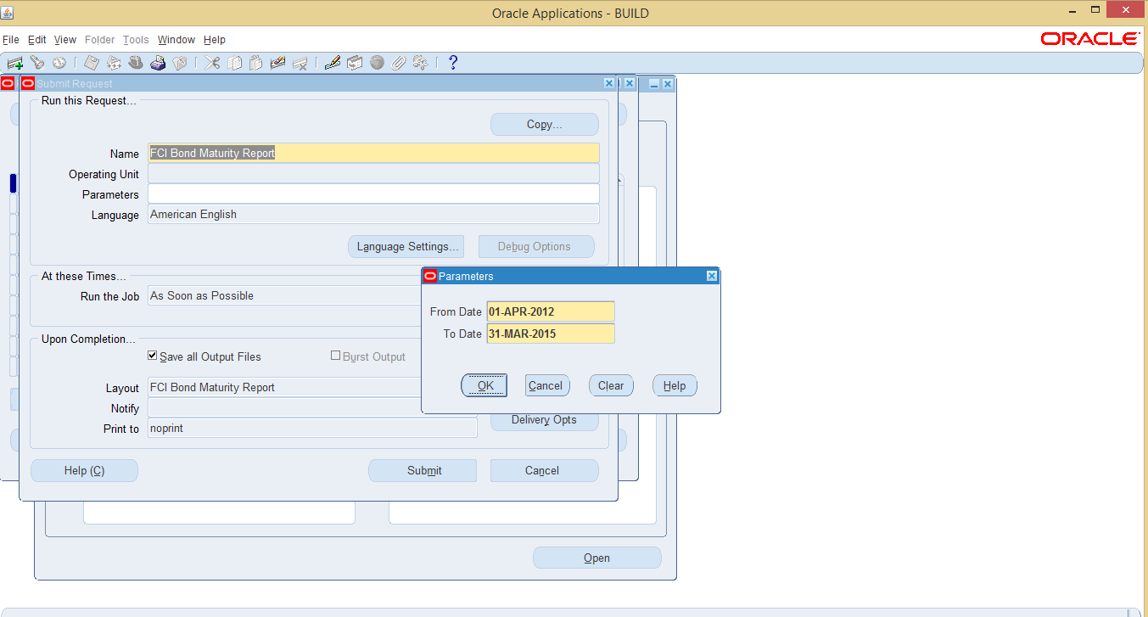
Output is attached below for reference:

Settlements Journal by Date Report:
This report can be used to view the deals which are validate, settled and accounted. The report can be executed after performing accounting of the deals.

The report has the following parameters:
Parameter | Required/Optional | Description
Company | Optional | The company through which party has performed deal.
Deal Type | Optional | For which deal , report has to be executed (Bond, ONC etc)
Deal Number | Optional | The deal number for which report has to be executed
Journal date from | Optional | Upper limit for journal date
Journal date to | Optional | Lower limit for journal date
Amount Type | Optional | Type of amount
Transaction amount | Optional | Amount of transaction in the deal.
GL Account | Optional | Code combination for which the report has to be executed
Transfer To GL | Required | View GL posted / Unposted deals.

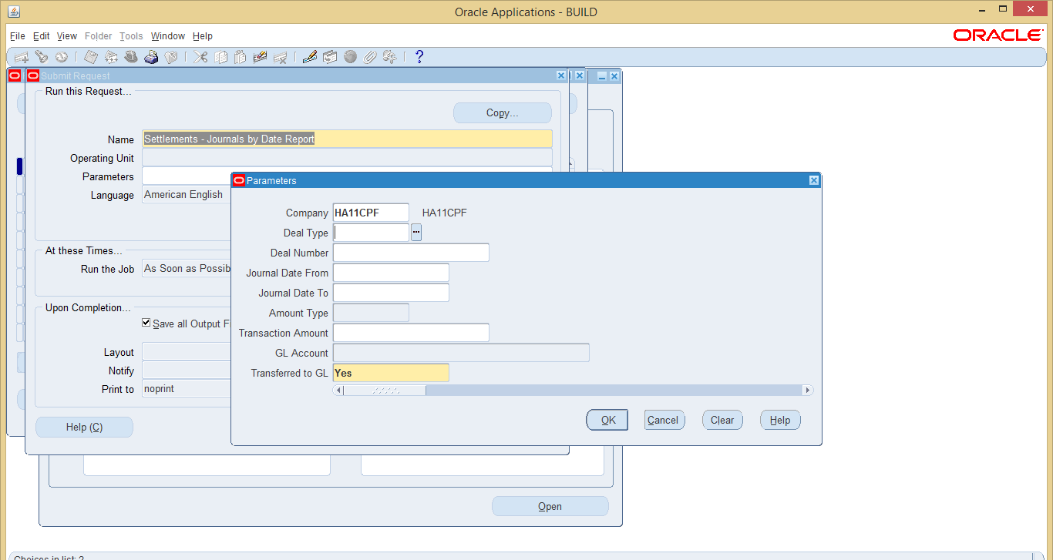

The sample output is attached below:

CPF Counter party Report

This is a discoverer report which fetches data for counter parties. The only execution parameter provided is party Code which is to be selected from the LOV. It brings all the details of a party like Party Code, Full Name, account, Currency etc.

Snapshot is attached for reference:

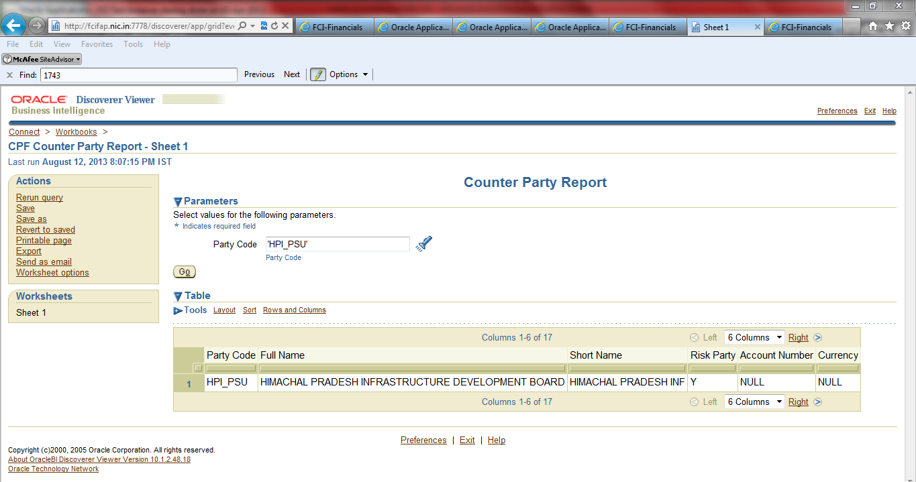

The output can be fetched in .csv format using the Export option provided. Sample output is attached below:

