Document: FCILekha Budgeting User Guide | Version:12.0



Error: Reference source not found

User Guide
Budgeting



MAY 2019

Confidentiality

© 2018 TECH MAHINDRA

This document contains information that is proprietary and confidential to TECH MAHINDRA, which shall not be disclosed outside Flex Industries Ltd, India, transmitted, or duplicated, used in whole or in part for any purpose other than its intended purpose. Any use or disclosure in whole or in part of this information without express written permission of TECH MAHINDRA is prohibited. Any other company and product names mentioned are used for identification purposes only, and may be trademarks of their respective owners.

Document Control

Revision Details

Date | Author | Version | Change Reference
March,2008 |  | 1.0 | Initial version
01-AUG-2013 | Rituparna Datta | 1.1 | Modified title no. 2,3,8,13
09-Sep-2013 | Nivediat Dey | 1.2 | Reports added
2-Dec-2015 | Nivedita Dey | 1.3 | CR 413
15-March-2016 | Avinash Kumar | 1.4 | R12 Screen Replacement

Distribution

Copy No. | Name | Location | Role | Position | Date

DOCUMENT RELEASE NOTICE

Notice No. :
Client : Food Corporation Of India
Project : Oracle Application 11i Implementation at Food Corporation Of India
Document Details:

Name | Version No. | Description
FCILekha User Guide-Budgeting | 12.0 | Training document for General Ledger - Budgeting

Revision Details:

Action taken  (Add / delete / change) | Preceding  Page No. | New  Page No. | Revision  Description

Change Register serial numbers covered:
The documents or revised pages are subject to document control.
Please keep them up-to-date using the release notices from the distributor of the document.
These are confidential documents. Unauthorized access or copying is prohibited.

Approved by: Date:

Authorized by: Date:

DOCUMENT REVISION LIST

Client : Food Corporation Of India
Project : Oracle Application 11i Implementation at Food Corporation Of India
Document Name: FCI Training Document – Budgeting
Release Notice Reference (for release):

Rev.  No | Revision  Date | Revision  Description | Page  No. | Prev  page no | Action  Taken | Addenda/New page | Release  Notice reference

Table of Contents

Overview 1
1. Define Budget 1
2. Define Budget Organization 2
3. Enter Budget Journals 4
4. Master Detail Budget Example 6
5. Budget Transfer 8
6. Budget Inquiry for Master/ Child Budgets 9
7. Budget Inquiry for Other Budgets 10
8. Funds Inquiry 11
9. Run Reports - Standard 13
10.1 FCI Budget Variance Report 14
10.2 Budget - Organization Listing 14
10.3 Budget - Journals by Flexfield 14
10.4 Budget - Summary/Detail 14
10.5 Trial Balance – Budget 14

Overview
The purpose of this training document is to give the intended users step by step operating instructions in doing the Budgeting related activities in Oracle Applications 12 ERP system.
The Budgeting module of the Oracle Applications 12 is configured to meet the requirements of financials of Food Corporation of India.
The system is configured as per the GL Set Up document. To perform Budgeting related activities in the configured system, it is essential for the business users to know the operating steps. In this context, the User Guide document is prepared and distributed to the intended users.
In case of FCI, Budgeting is to be done up to the District Level. Just as the nomenclature of units ending with ‘00’ are followed for the parent account, the nomenclature earmarked for the Budgeting unit is the unit ending with ‘99’. No Budgeting or Posting is allowed for parent accounts. Hence the Budgets would be allocated to the units ending with ‘99’. ‘CC01’ is the unit marked out for the costing super parent.

The Budget hierarchy of FCI is depicted as follows:
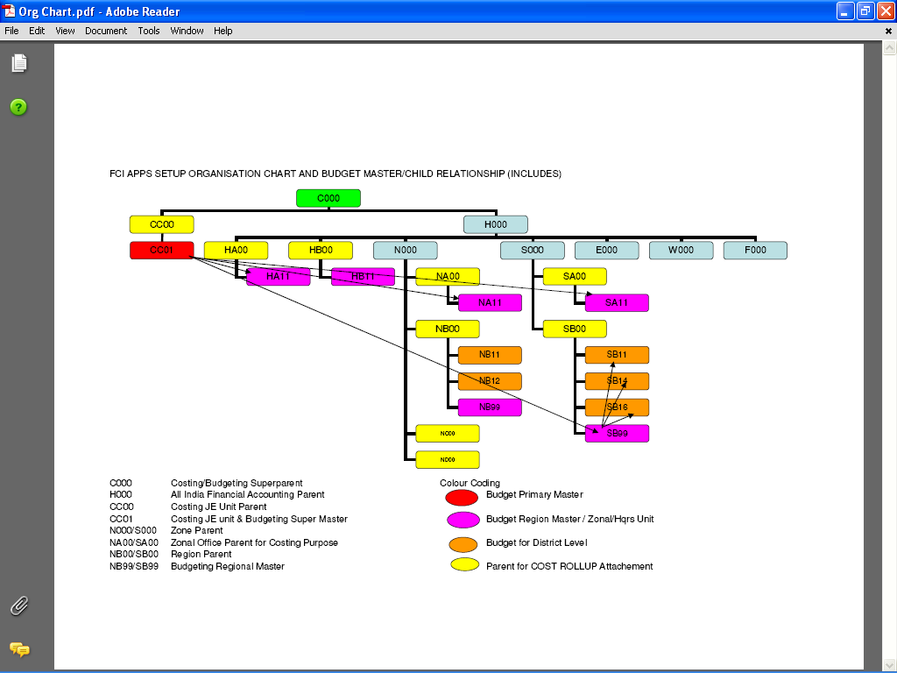

Define Budget
Function Path: Budgets >> Define >> Budget
Note: As FCI follows an annual budgeting cycle, Budgets need to be created every year.
Steps:
- Enter the name of the budget, description of budget
- Select the status of the Budget. The possible options are ‘Open’, ‘Frozen’, ‘Current’. Only one Budget can be ‘Current’ at a time. Other Budgets would be ‘Current’ or ‘Frozen’. No changes are permitted in the Budget once the status is set to ‘Frozen’.
- Check require budget journal check box for the budget amounts to be entered through budget journal entry. Since, this is set up at Ledger level, this option flows down to all the budgets.
- Enter the Budget period for the budget.
- Assign a Master Budget to the Child Budget. The Master Budget must have the same period as the Child Budget.
- Click on Open Next Year. After this is clicked, General Ledger displays the Latest Open Year in the budget.
- Auto Copy feature cannot be used if the budget has any open years. Hence, if this feature is required to be used, it will have to be done before clicking on Open Next Year.

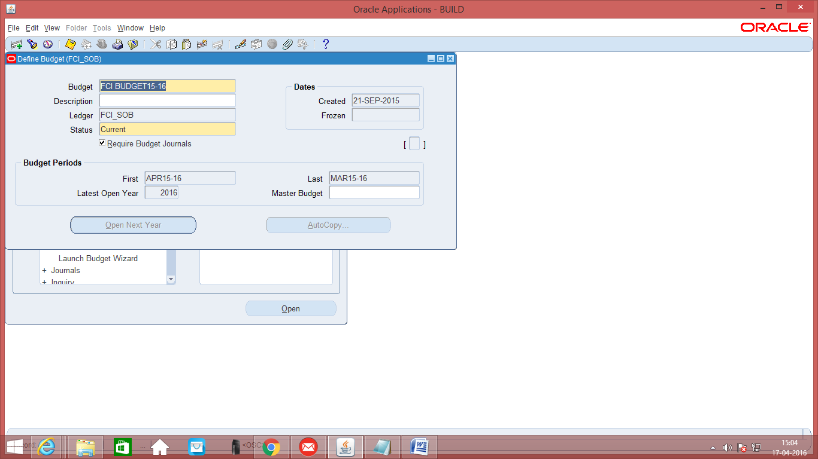

Define Budget Organization
Function Path: Budgets >> Define >> Organization
Note: Budgeting Organization need to be created only once. However, budgets have to be created every year.
Steps:
- Enter the name of the budget organization, description of budget organization.
Note: The Organization naming convention that needs to be followed is, the starting 4 character should be any unit name e.g. ‘HA11 BUDGET’.
- The display sequence has to be entered as 1, 2, 3,4,5,6 and 7.
- Budget Organizations can be protected with Password Security by clicking on Set Password.
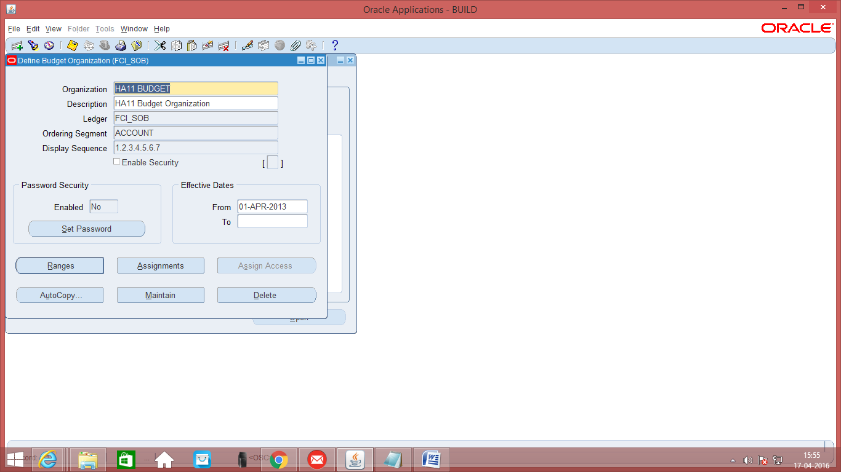
- Ensure that the accounts to be entered in Budget Organization exist in the Account Combination. For this pass a manual Journal entry with amount as Rs. Zero to create an account combination. Procedure to create a manual Journal Entry is explained in Step 5: Creating a Zero Amount Manual Journal Entry.
OR
Creating Account Combinations can also be achieved through Setup. However, this would be available to only those users who have access to Set Up. For this, navigate to
Function Path: Set Up >> Account >> Combination and enter the Account Code Segment
OR
Auto copy in the Budget Organization will also create the requisite combinations by giving override in the Unit Segment.
- Choose Ranges Button. The next screen opens up.

- Enter the Account Range, type, Currency, Amount type.
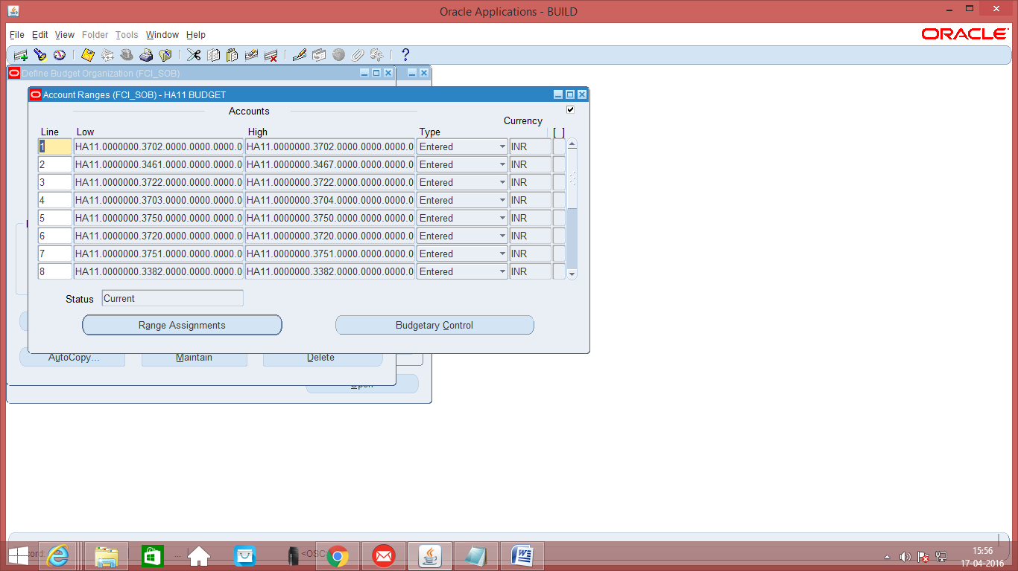
Select the funds level check – Absolute, Advisory or None.
None: Do not perform budgetary control for the Accounting Flexfields in the range.
Advisory: Check or reserve funds for the Accounting Flexfields in the range. General Ledger reserves funds whether or not there are funds available. If sufficient funds are not available, you will receive a warning message.
Absolute: Check or reserve funds for the Accounting Flexfields in the range. General Ledger reserves funds only if sufficient funds are available.
- Enter the amount type as ‘YTD’ and the Boundary as ‘Year’. This combination will set the budget for a year and will also monitor it on annual basis. With this combination there will be no checks as to how the budget is spent within the year. To illustrate, it will allow the entire spending to take place in the first month of the budget. To put restrictions on usage within a period, the amount type could be ‘PTD’ and the boundary as ‘Year’
The available combinations are:
PTD | General Ledger checks your funds based on the period-to-date funds available balance
QTD | General Ledger checks your funds based on the quarter-to-date funds available balance
YTD | General Ledger checks your funds based on the year-to-date funds available balance
  Period | General Ledger checks your funds based on the funds available balance as of the end of the period of the current transaction.
  Quarter | General Ledger checks your funds based on the funds available balance as of the end of the quarter of the current transaction.
  Year | General Ledger checks your funds based on the funds available balance as of the end of the year of the current transaction.
IMPORTANT NOTE: Whenever, accounts are added, deleted to a Budget Organization, the program Maintain Budget Organization has to be run. This is done by clicking on the ‘Maintain’ Button.

Enter Budget Journals
Function Path: Budgets >> Enter >> Journals
Steps:
- Enter the name of the budget organization. Select the name of the budget
- Enter the from / to accounting period. The accounting period for FCI will be shown as spread across the periods April to January and the second period from February to March. The accounting period comes split into two lines, because the Accounting period can only display 13 periods at a time. Since the FCI calendar after inclusion of adjusting periods has more than 13 periods, the accounting range comes split into two ranges in two lines.
- Enter currency.
- Enter the period wise budget amounts for each account assignment in worksheet mode/ single row mode/ journal mode.
- IMPORTANT NOTE: Enter in the account combination. The account combination being entered must exist in the accounts assigned to the Budget Organization and the combination must be defined. If it does not exist in the Budget Organization, it will give an error that query caused no records to be retrieved. For defining the account combination, please see 2. Define Budget Organization Point e.
- Enter in the amounts. The amounts may be spread over periods or entered in the month. Since FCI follows annual budgeting, the boundary for checking whether budgets are exceeded would be a year.

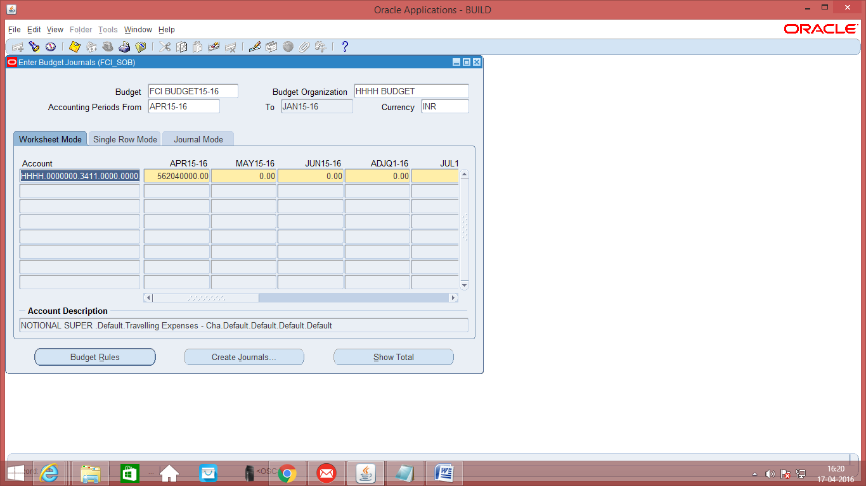

- Click on Create Journals Button and enter the name of the Journal batch and journal category. Check the funds, Reserve funds and then click on Done. Budgets cannot be reduced once the amount has been spent. Once amount has been entered and journal created, the same can only bre reduced to the extent no financial transaction has been made. Otherwise, the journal would fail the fund availability test.

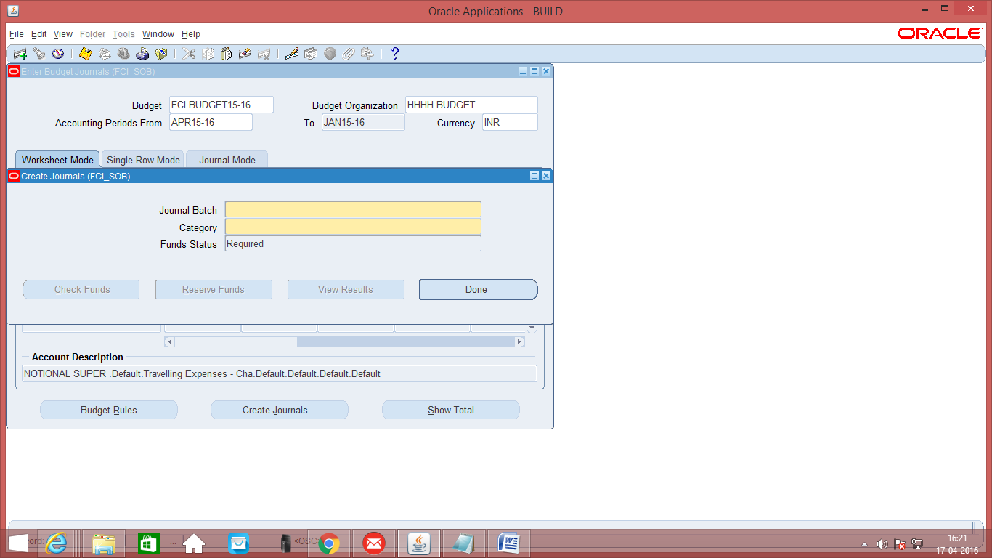

- Post the Journal. Posting would be done automatically by the system, within specified interval of 24 hours.

Master Detail Budget Example
Master Detail Budgets are made whenever Budgeting hierarchies are required. The procedure for Budget allocation is that the Head Office allocated budget to the Zonal Office and to the Regional Offices.
This is illustrated with one example of zonal office and regional office.
SSSS
(Notional unit to which budget is allocated for south zone)
SA11
(unit to which budget is allocated)

SBRO
(Notional RO to which budget is allocated)

SB11
SB12
SB13
Upto SB98

Value | Name | Children | Remarks
SSSS | Notional Unit for South Zone | Not a parent | The unit is the top most unit of South Zone
SA11 | ZO (South) | Not a parent | SSSS unit will transfer budget to this unit. The unit is a leaf unit of south zone.
SBRO | Notional Unit for regional units (South) | Not a parent | SSSS unit will transfer budget to this unit. The unit is the parent of Regional office.
SB11 | Regional Unit | Not a parent | SBRO unit will transfer budget to this unit. The unit is a leaf unit of one region of south.
SB12- SB98 | District Unit | Not a parent | SBRO unit will transfer budget to this unit. The unit is a leaf unit of south region.

Steps:
- Create a Budget as defined in point 1 : Define Budgets
- Define Budget Organization for each unit including notional unit. Refer point 2. Here, create budget organization for each unit, SSSS, SA11, SBRO, SB11, SB12 – SB98.
- Assign the accounts to the Budget Organization. Refer point 2 and 3.
- Enter the budget amount for the top most organization. Here, budget amount needs to be assigned only on SSSS unit. Please refer point 6.
- Transfer budget from one organization to another organization as per hierarchy. Here, SSSS will transfer budget to SA11, SBRO. SBRO will further transfer budget to SB11, SB12- SB98. For budget transfer, please refer point 9.
- The Master Detail budget is now set up and can be inquired upon.

Budget Transfer
Function Path: Budget >> Enter >> Transfer
Steps:
- Budget Amounts can be transferred only WITHIN the same budget
- Budgets can be transferred across Budget Organization or within Accounts in the same Budget Organization.
- Fixed amounts or a percentage of budgets balance can be transferred.
- Enter the name of the Budget, the budget organizations.
- Enter the accounts across which the Budget is to be transferred. The Accounts must exist within the budget organizations.
- Click on Transfer Amounts
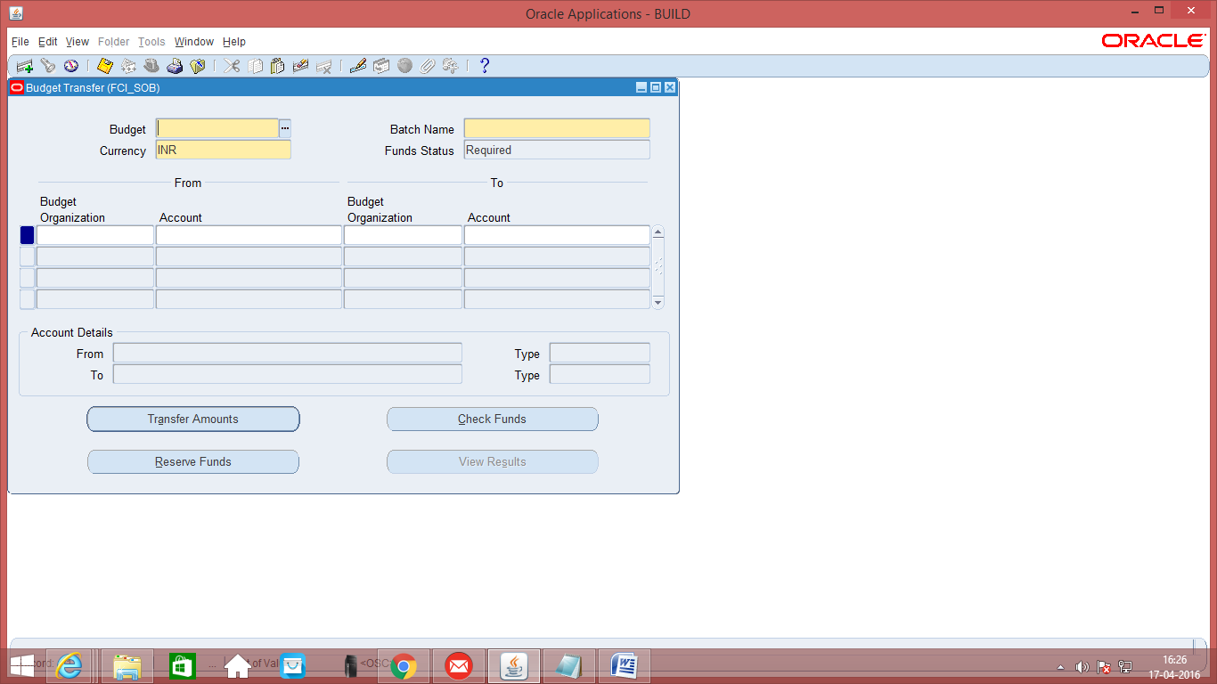
- Enter the amounts or the percentage to be transferred. Save.
- Come back to the previous screen. Click on check funds, reserve funds.
- Post the transaction. This will be done automatically within 24 hours. For immediate posting follow the steps in Step 5 – Journal Posting.

Budget Inquiry for Master/ Child Budgets
For inquiry into Master / Child Budgets:

Function Path: Inquiry >> Budget

Steps:
- Enter the name of the Master Budget in the Budget column.
- Enter the name of the Summary Template. To see all the summary accounts belonging to the template, just click on ‘OK’ without entering any of the accounts.

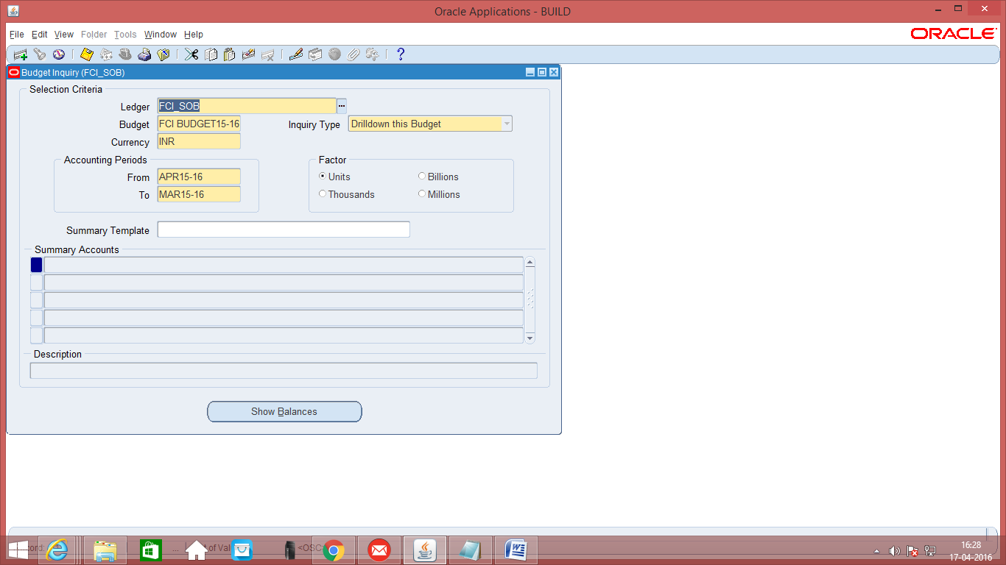
- Click on ‘Show Balances’ to see the balances for a particular period.

Budget Inquiry for Other Budgets
For inquiry into Budgets which are not Master / Child Budgets:

Function Path: Inquiry >> Account

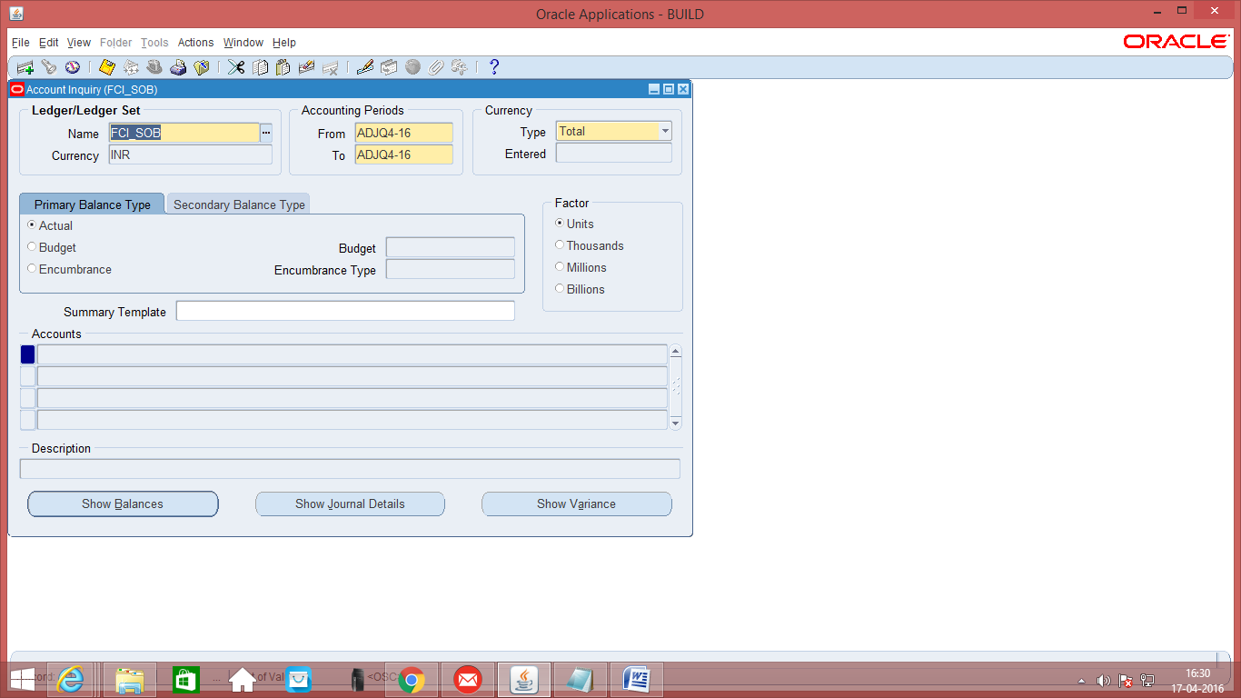

Steps:

- Select the Accounting Period
- Select the primary Account Balance Type as ‘Budget’
- Select the name of the Budget
- To see all accounts belonging to the Budget, click on ‘OK’ in the account region, without selecting any account.
- Click on ‘Show Balances’ to see details of the budgeted amounts for the account , Journal Details and variance for the account.

Funds Inquiry
To check the fund available in an account, use the fund inquiry:

Function Path: Inquiry >>Funds

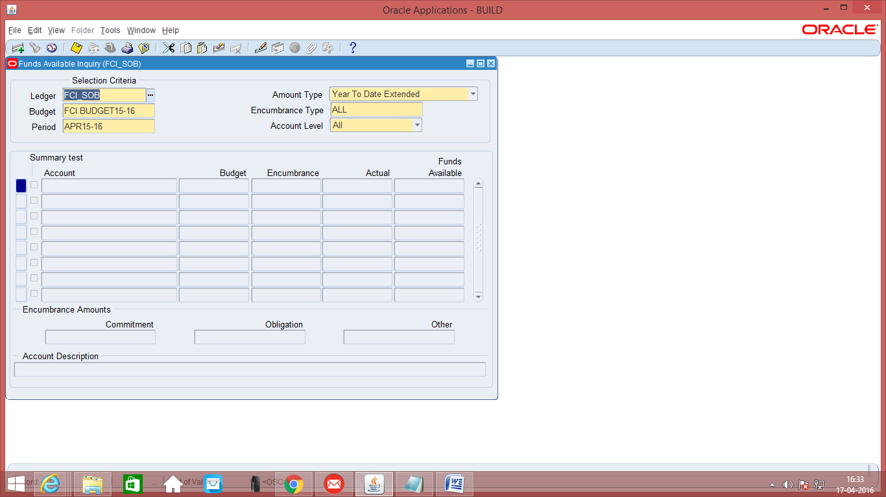

Steps:
- Select the name of the Budget
- Select the Accounting Period
- Select the Amount Type
- Then click on the Account line. This will open a form where user has to provide accounting lines.
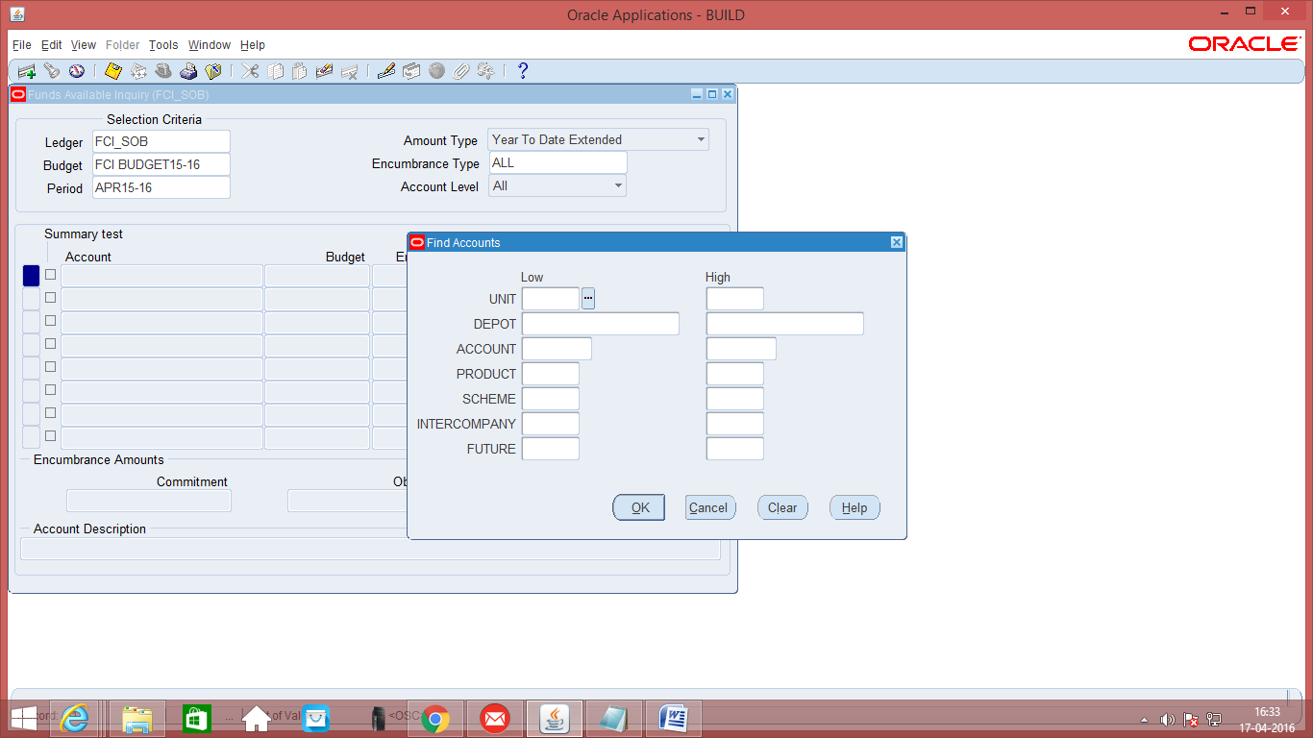

- Provide the range and click Ok.

Run Reports - Standard
Function Path: Reports >> Request >> Standard
Alternative Function Path: From the Menu Bar at the top, view Requests.
Steps:
- Click on Standard, then choose single request if only one report is required. If it is required to submit a predefined set of report sets.
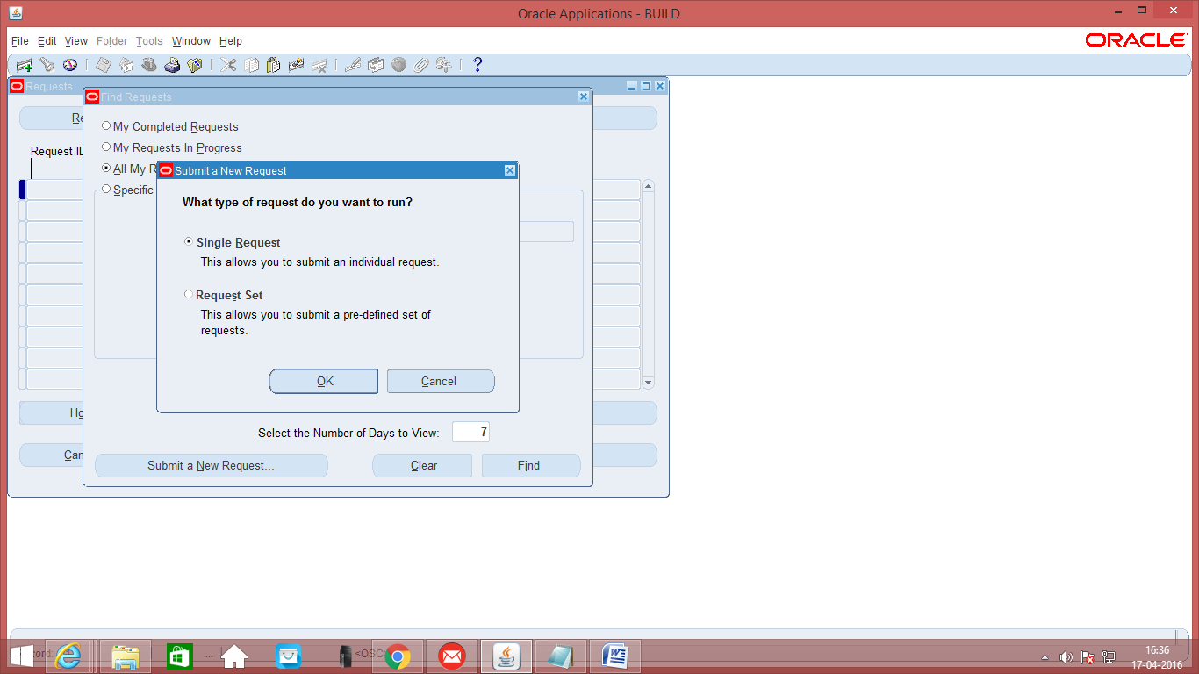
- Select the report / request set to run and submit the request.
- Select the Budgeting Reports for example Budget Master/ Detail Report. Customized Reports for FCI are available proceeding with FCI. These are FCI Quantitative Budgets Variance Analysis report and FCI Budget transfer report.

10.1 FCI Budget Variance Report
This is a customized report which shows the variance of budget allotted to an organization and the total expenditure till the period.
It has three input parameters:
- Budget Name
- Period
- Organization
The output of this report is in excel format.

10.2 Budget - Organization Listing
This is a seeded report which fetches the details of the assignment to an organization.
It has one input parameter:
- Budget Organization
The output of this report is in text format.

10.3 Budget - Journals by Flexfield
This is a seeded report that fetched the status and details of the budget journals for a particular account, currency, and fiscal year.
This report prints the status, period, batch name, journal entry name, journal entry line number, description, entered debit or credit amount, and statistical amount for each account requested.
It has four input parameters:
- Budget (Budget Name)
- Accounting Flexfield
- Currency code
- Year
The output of this report is in text format.

10.4 Budget - Summary/Detail
This is a seeded report that displays the detail accounts that roll up into a summary account for a specific budget and currency. This report shows the balance and journal information for each detail account for the period you specify.
It has four input parameters:
- Budget
- Summary Account (Choose a summary account in your set of books.)
- Currency
- Period
The output of this report is in text format.

10.5 Trial Balance – Budget
Use this report to Review general ledger budget account balances and activity for a specific currency.
It has five parameters:
- Budget Name
- From Period
- To Period
- Currency type
- Currency

