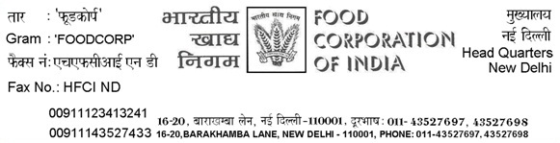

No.I.12/ FAP/implementation/2013 Dated: 08.02.2013
Circular No. FAP/04/2013
Sub: Status report on Closing of Accounts through FAP

- Reference is made to Circular No FAP/03/2013 dated 28.01.2013 regarding closing of accounts for the year 2012-13 through FAP by selected sites wherein it has been prescribed vide above circular to provide weekly status of the reconciliation and review at zonal level.

- The status of the weekly progress shall be furnished to the regional offices / zonal offices and this office on weekly basis after following the procedure given in circular No FAP/02/2013 dated 28.01.2013 in the enclosed format at Annexure I.

- The regional offices and Zonal offices shall review the status on weekly basis and ensure that the reconciliation is completed by the dates given in the circular No FAP/03/2013 failing which appropriate action would be taken against the defaulting units & their controlling offices.

(R R Aggarwal)
General Manager (FAP)
Distribution:
1. CGM (Cost/Fin./A/Cs/IA/Funds/CPF) in Headquarters
2. All CGM/GM (F&A) in Zonal offices
3. The Director, IFS, FCI, Gurgaon, Haryana.
4. All Dy. GM (F&A)/ Asstt. GM (A/cs) FCI, Regional Offices.
5. All Area Managers.
Annexure

